

Medication Management and Dosage Reminders

Prepared by:
Sedra Al-Arouri - Raghad Hredeen - Ahmed Al-Homsi

Supervised by:
Dr.Bader Ahmed
Eng.Farah Fares

2025 – 2026

Abstract:

This project introduces a comprehensive web-based platform designed to bridge the communication gap between physicians and patients while ensuring strict medication adherence. The system features a dual-interface architecture where doctors can monitor multiple patients, prescribe digital medications, and manage treatment plans effectively. A core functionality of the system is the Intelligent Alert Mechanism, which provides real-time notifications for scheduled dosages.

To ensure patient safety, the system implements a persistent follow-up logic; if a patient fails to confirm medication intake, the system triggers repeated alerts specifying the missed dose time. Furthermore, the platform includes an Inventory Tracking Feature that monitors medication quantities and notifies the patient when a refill is required. From a clinical perspective, the system provides doctors with a Drug-Interaction Detection tool, allowing them to identify and resolve potential medication conflicts before finalizing a prescription. This integrated approach leverages modern web technologies to minimize human error, manage inventory, and optimize the overall therapeutic process.

المحتويات
chapter1 12
Introduction 12
1.1Objective 13
1.2 Project Scope 13
1.3 Technical Scope: 14
chapter2 16
Project management 16
1. introduction: 17
2. project charter: 17
project objectives: 17
3. statement of work(sow): 19
3.1 project Description: 19
3.2 Project Scope: 20
3.3 Project Objectives: 20
3.4 Deliverables: 20
3.5 project Requirements: 21
Technologies and Tools 21
3.6 Assumptions: 21
3.7 project Resources: 22
Human Resources: 22
3.8 Schedule: 22
4. WBC "Work Breakdown Structure": 23
Work Breakdown Structure: 24
5.Project Plan – Gantt Chart: 25
6.Risk management: 26
26
Configuration Management System : 34
1. Introduction to Configuration Management 34
2. Configuration Items (CIs) 34
3. Configuration Identification 35
4. Configuration Control 36
5. Configuration Status Accounting 36
6. Configuration Auditing 37
7. Configuration Management Applied to Architectural Evolution 37
Conclusion 38
5. Summary: 38
chapter3 39
Fundamental Concepts and Literature Review 39
1. Introduction 40
2. Software Architecture Patterns 40
2.1 Microservices Architecture 40
2.2 Client-Server Model 40
2.3 Repository Pattern 41
2.4 Middleware and Request Pipeline 41
2.5 Dependency Injection (DI) 41
3. Literature Review: 42
3.2 Comparative Analysis of Reviewed Systems 45
4. Conclusion of Literature Review 46
5. Tools and Technologies 46
5.1 System Development Technologies 46
5.2 Database Management Architecture 46
Summary 47
Table 3.1: A brief analysis of similar systems and the target system. 48
chapter4 49
System Analysis 49
1. Introduction 50
2. Software Requirement Specification (SRS): 50
The specification includes the following key elements: 50
3. Software Requirement Specification (SRS) 51
1. Introduction 51
1.1 Purpose 51
1.2 Project Scope 51
1.2.1 High-Level Requirements 52
1.2.2 Actors: 53
2. General Description 53
2.1 Product Perspective 53
2.2 Product Features 54
2.3.2 Doctor 54
2.3.3 System Admin 55
3. System Features 55
3.1 Functional Requirements 55
3.1.1 Account Management 55
3.1.2 Medication Management 55
3.1.3 Content Extraction 56
3.1.4 Classification and Search 56
3.1.5 Medication Lifecycle Management 56
3.1.6 Audit Logging 57
3.1.7 System Administration 57
3.2 Non-Functional Requirements 57
4. System Requirements 59
5.Use Case Diagram 60
5.2System Features _ Use Case Description 61
•login ( UC-01 ) - use case specification :………………….. 61
•Search Documents ( UC-02 ) - use case specification :…………………… 61
•Add User ( UC-03 ) - use case specification :………………….. 62
•View Document ( UC-04 ) - use case specification :……………………. 62
•Delete Document ( UC-05 ) - use case specification :………………….. 63
•Edit Document ( UC-06 ) - use case specification :………………… 63
•Check Permissions ( UC-07 ) - use case specification :……………………. 64
•Reset Password ( UC-08 ) - use case specification :……………………. 65
•Upload Document ( UC-09 ) - use case specification :……………………. 65
•Generate Reports ( UC-10 ) - use case specification :…………………… 66
5.3 Sequence Diagram: 67
5.4 Activite Diagram: 81
5.5 Analysis Class Diagram: 94
5.6ERD Diagram:…………….. 95
5.Initial Requirement Trackability Matrix (RTM): 96
Chapter5 98
System Design 98
1. Introduction: 99
2. System Architecture: 99
3. Component Diagram: 100
Component Functions 102
Chapter 6 104
Practical implementation 104
Introduction 105
Tools and Technologies Used 105

chapter1

Introduction

1.Introduction:

1.1Objective
The Intelligent Medication Management and Dosage Alert System aims to establish a secure and efficient digital platform for managing patient treatments and prescriptions. The system allows doctors to prescribe digital medications, monitor multiple patients remotely, and utilize a drug-interaction detection tool to resolve potential conflicts. It also provides patients with real-time notifications for scheduled dosages and triggers repeated alerts if a dose is missed to ensure strict adherence. Furthermore, the platform integrates inventory tracking to notify users when a medication refill is required, thereby optimizing the overall therapeutic process.

1.2 Project Scope
The project scope defines the boundaries of work and the technical functions covered by the system. It is divided into three main phases.

1.2.1 Phase 1 (MVP) – Core Functions
- Register and manage doctor and patient profiles securely.
- Allow doctors to enter and update digital prescriptions.
- Implement a basic scheduling engine for medication timings.
- Provide a dashboard for patients to view their current treatment plans.
- Store and retrieve patient data using a structured SQL database designed via QuickDBD.

1.2.2 Phase 2 – Advanced Features
- Generate detailed treatment adherence reports for doctors.
- Improve the patient user interface for better accessibility on various devices.
- Implement a persistent alert mechanism that repeats until the dose is confirmed.
- Manage user roles and permissions (Doctor, Patient, Caregiver).
- Detect potential drug-to-drug interactions before finalizing a prescription.

1.2.3 Phase 3 – Expansion and Integration
- Integrate with external pharmaceutical databases via APIs for accurate drug information.
- Enable automated medication identification using image processing.
- Provide predictive analytics for medication inventory to prevent shortages.
- Enhance end-to-end encryption for sensitive patient health data.
- Improve system performance to handle a growing number of concurrent users and medical records.

1.3 Technical Scope:
The system’s scope includes all technical aspects required to build an effective and secure healthcare management platform that supports patients and medical professionals.

1.3.1 Frontend:
Design and development of responsive web interfaces using modern frameworks, supported by interactive libraries to ensure a smooth user experience for medication tracking.

1.3.2 Backend:
Using specialized backend environments to implement the system’s logic, enabling efficient scheduling of dosages and secure management of patient profiles.

1.3.3 Database:
Using a structured relational database, designed with QuickDBD, to store prescriptions, patient histories, and medication logs in a secure and organized manner.

1.3.4 Image Processing Services:
An advanced image processing module using OpenCV and NumPy was integrated to analyze medication packaging and identifying labels. This feature provides high efficiency in automating medication tracking and reducing manual data entry errors.

1.3.5 Security:
The system implements robust security protocols, including data encryption and secure user authentication. These measures protect sensitive medical records against unauthorized access to ensure the confidentiality of patient health information.

1.3.6 Integration:
The architecture is designed to support seamless integration between the image processing engine, the dosage alert system, and the SQL database. This ensures a unified and consistent data flow across all system modules, from prescription entry to patient notification.

chapter2

Project management

1. introduction:
In this chapter, we will examine the project management phase, which includes: Project Charter, Project Plan, (Statement of Work - SOW), Work Breakdown Structure (WBS), Project Management Strategies and Risk Management Strategies. The project is designed to guide and control the project effectively. The project is a preliminary step towards completion.

2. project charter:
The project charter is a formal document that requests official authorization to initiate the project. It serves as a reference point throughout the project, clearly stating its purpose and establishing a foundation for decision-making and project management.

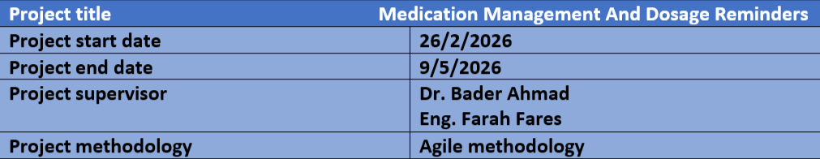

project objectives:
- Establish a secure digital system for managing patient prescriptions and dosages efficiently.
- Incorporate image processing services using OpenCV to identify medications accurately.
- Implement persistent and real-time alert mechanisms to ensure patient adherence to treatment schedules.
- Provide doctors with advanced tools to monitor patient compliance and detect drug-to-drug interactions.
- Automate inventory management to notify patients when medication supplies are low.
- Design a structured database using QuickDBD to ensure data integrity and security.
- Integrate with external pharmaceutical databases via APIs for accurate drug information.
- Improve system performance and scalability to handle a growing number of medical records and concurrent users.

Project Approach:
The Intelligent Medication Management and Dosage Alert System will be developed gradually in phases using the Agile methodology. Each phase focuses on specific priorities to ensure medical data integrity and system reliability:
User & Profile Management:
Develop secure registration and login for medical staff (doctors) and patients with role-based access control.
Prescription Management:
Enable doctors to digitally prescribe medications, set dosage timings, and link them directly to patient accounts.
Inventory & Dosage Tracking:
Add, update, and track medication stock levels to notify users when refills are necessary.
Automated Image Recognition:
Process medication labels and packaging using OpenCV to extract identification details for automated tracking.
Notification & Alert Engine:
Provide persistent real-time alerts for scheduled dosages and repeated notifications for missed doses to ensure adherence.
Reporting & Analytics:
Generate detailed adherence reports for doctors and analyze potential drug-to-drug interactions.
Integration & Expansion:
Connect with external health APIs, enhance data encryption, and support system scalability for wider clinical use.

Stakeholders:

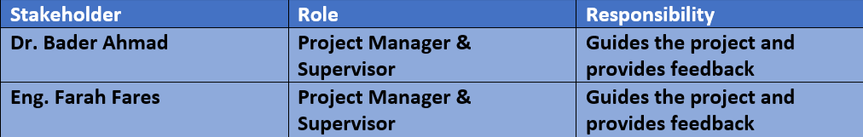

3. statement of work(sow):
The Statement of Work is a comprehensive document that defines the scope of work for the project, including specific tasks, deliverables, schedules, and responsibilities. It provides a clear understanding of what needs to be accomplished, the project's objectives, and success criteria.

3.1 project Description:
The Intelligent Medication Management and Dosage Alert System project aims to automate and manage patient prescriptions securely and efficiently. The system provides functionalities for digital prescribing, patient monitoring, and medication identification using image processing technology via OpenCV. It also supports persistent notification triggers, inventory tracking, and drug-interaction analysis to enhance patient safety and treatment adherence.

3.2 Project Scope:
The system is designed to:
- Automate medication scheduling and dosage tracking.
- Provide secure digital prescription management for doctors and patients.
- Enable real-time, persistent dosage alerts to ensure patient adherence.
- Support automated medication identification using OpenCV and image processing.
- Offer advanced drug-interaction analysis to enhance patient safety.
- Generate detailed adherence reports and maintain medication logs.
- Integrate with inventory management to monitor medication stock levels.

3.3 Project Objectives:
- Enhance patient safety through accurate medication management.
- Improve treatment adherence by reducing the risk of missed dosages.
- Provide secure remote access and role-based permissions for medical staff.
- Support medical decision-making through data-driven reporting and analytics.
- Ensure system reliability and data integrity for sensitive medical information.

3.4 Deliverables:
- Project Plan and Timeline.
- SRS Document (Software Requirements Specification).
- Final Project Report.
- Functional Frontend and Backend components of the Intelligent Medication Management system.
- Relational Database Model designed via QuickDBD.

3.5 project Requirements:

Technologies and Tools
- Backend Environment: Python-based frameworks for logic and API management.
- Frontend Framework: Modern web technologies for responsive UI.
- Database: SQL-based relational database.
- Database Design Tool: QuickDBD.
- Image Processing Libraries: OpenCV, NumPy, and Matplotlib.
- Development Tools: Visual Studio Code and GitHub.
- Project Management Tools: Microsoft Excel for timeline and Gantt charts.

3.6 Assumptions:
- Continuous availability of project team members (Sedra and Raghad) to collaborate on system integration.
- Regular academic supervision and feedback throughout the development phases.
- Stable access to required Python libraries and database management tools.
- Consistent availability of hardware resources for testing image processing algorithms.
- Commitment of all team members to follow the Agile methodology and meet the project deadline of May 16, 2026.

3.7 project Resources:

Human Resources:
- Sedra Al-Aroury: Software Engineer & Project Manager.
- Raghad Hureideen: Software Engineer & Project Manager.
- Ahmed Al-homsi: Software Engineer & Backend Developer.

3.8 Schedule:
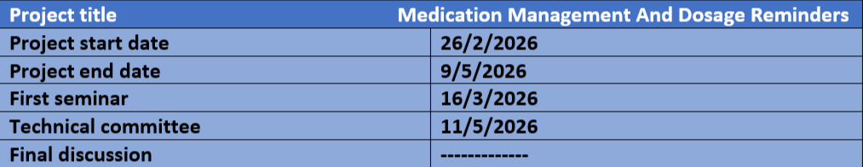

4. WBC "Work Breakdown Structure":
The WBS is a diagram known as the Work Breakdown Structure. It is used in project management to divide large-scale work into smaller, manageable sections that lead to better outcomes.

The WBS is usually represented in a hierarchical format that shows the sequential breakdown of activities and tasks within the project. The main project (parent project) is placed at the top, followed by levels of sub-elements branching from it. These are further divided into smaller, more detailed work elements until each task is clearly defined.

The WBS provides a comprehensive view of the project's structure and details. It helps clearly define the scope of work and assign specific responsibilities to each element in the project. It is also used to facilitate planning, organize resources, estimate costs, and monitor progress.

Work Breakdown Structure:
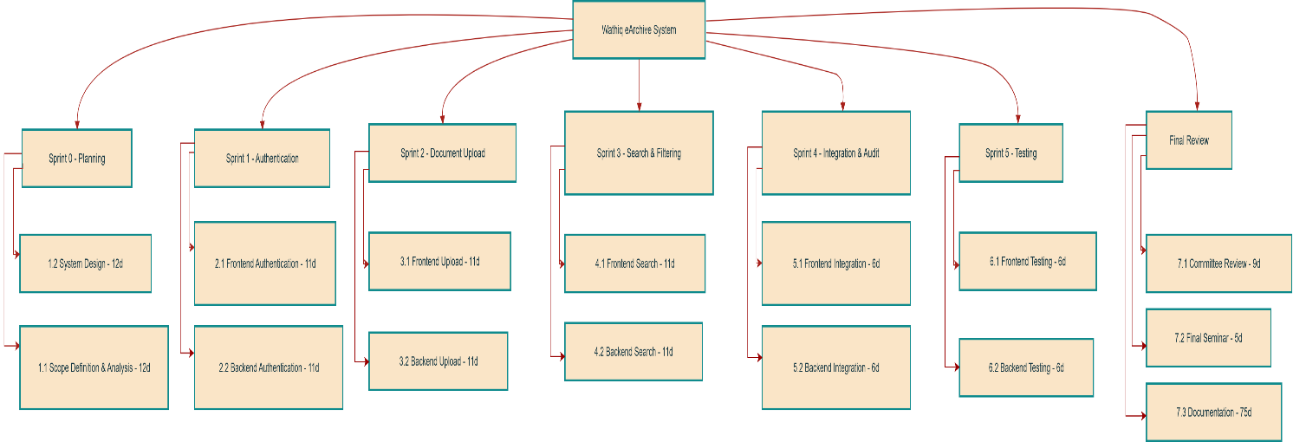

5.Project Plan – Gantt Chart:
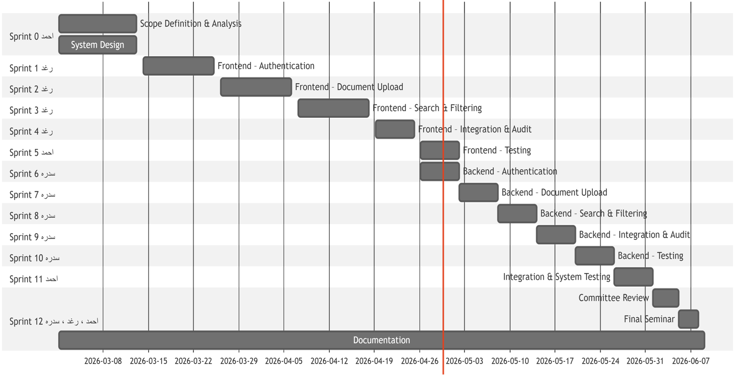

6.Risk management:
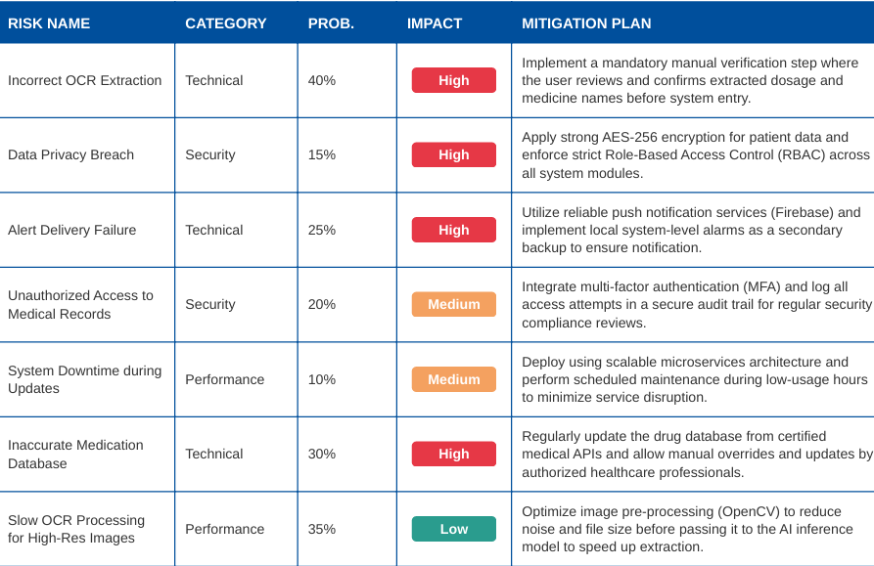

Configuration System (Version Control & Configuration Management)
1. Project Description
The project, Intelligent Medication Management, is a smart healthcare system designed to digitize medication prescriptions and transform them into searchable and categorized digital data using artificial intelligence techniques.

The system allows users to upload prescriptions, manage medication metadata, and apply OCR (Optical Character Recognition) to extract dosage instructions and support future intelligent alerting and scheduling features. During development, the system evolved from a monolithic architecture into a more scalable microservice-based architecture, particularly for the OCR and Alert functionalities.

2. Git Repository Structure
The project is managed using Git and hosted on GitHub.
The repository contains the complete backend source code of the system.
The OCR and Dosage Alert functionality was later extracted into standalone microservices to improve scalability and separation of concerns.

Repository link:
https://github.com/SedraNader/Medication-Management-System.git

Repository structure highlights:
- Application: Application layer (DTOs, interfaces, medical logic services)
- Domain: Core domain models (Patient, Medication, Dosage-related entities)
- Infrastructure: Persistence, repositories, and technical implementations

- Presentation: API controllers for dosage alerts and patient management.
- Medication.OcrService: Independent OCR microservice extracted from the main system to handle prescription image processing.

This structure follows clean architecture principles and clearly separates concerns between layers, ensuring that the medication logic is isolated from the image recognition services.

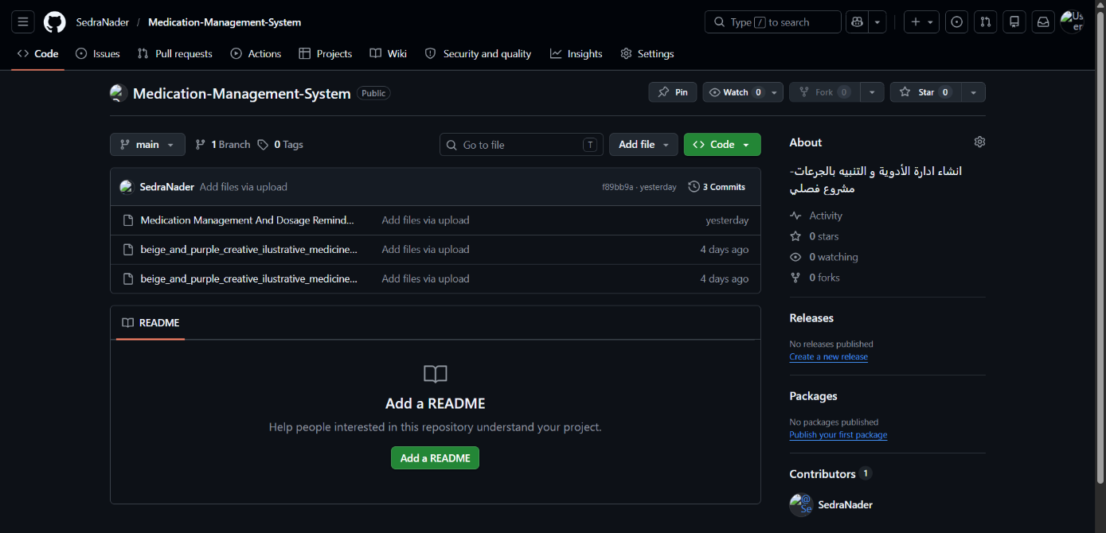

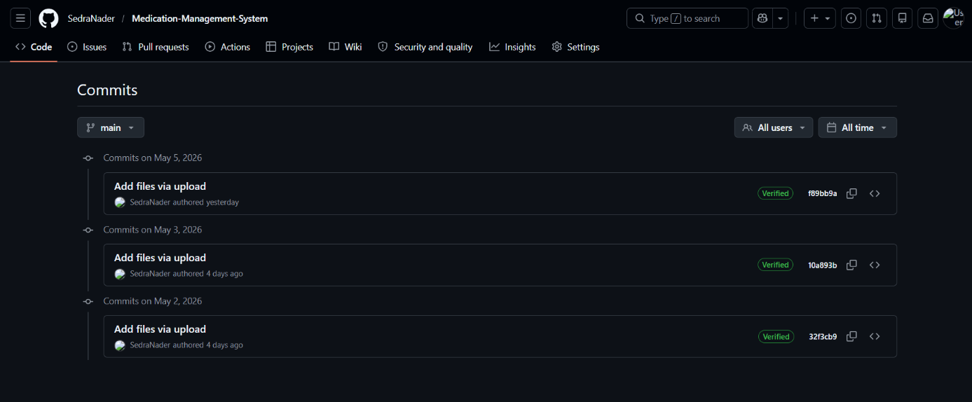

3. Branching and Merging Strategy
The project follows a feature-based branching strategy:
- main: Stable production-ready branch.
- feature/ocr-integration: Initial OCR integration for processing prescription images.
- feature/dosage-alert-service: Development and refactor of the dosage notification engine.

In addition to the backend branches, frontend development was implemented using
a dedicated feature branch:
- Medication_FrontEnd: Frontend user interface development and patient dashboard integration.
The frontend branch followed the same workflow, where changes were reviewed and merged into the main branch using Pull Requests after validation.

Branching workflow:
- Development starts by creating feature branches from the main branch.
- New features are implemented in dedicated feature/* branches.
- Each feature branch is merged into main using Pull Requests (PRs).
- Code changes are reviewed before merging.
Example:
- OCR was first implemented in feature/ocr-integration.
- Later, the dosage alert logic was refined in feature/dosage-alert-service.
- The refactor was merged into main using a Pull Request with no conflicts.

This approach ensured safe evolution of the system architecture.
All changes were merged using Pull Requests after review.

4. Team Members and Responsibilities
The Intelligent Medication Management project was developed by a team of three members, following an agile sprint-based development plan. Responsibilities were distributed across different sprints, covering frontend, backend, system design, security, AI features, and documentation.
Team Members:
- Sedra
- Raghad
- Ahmed
Roles and Responsibilities
Sedra – Backend Developer & System Architect
Responsible for the core backend development and architectural decisions, including:
- Designing the overall system architecture.
- Backend implementation for user management and authentication.
- Medication and prescription data management (backend).
- OCR integration and refactoring OCR into an independent microservice.
- API design and backend logic for dosage alerts, schedules, and patient logs.
- Backend security and quality improvements.
- Participating in AI-related backend features.
- Managing Git branches, Pull Requests, merges, and version tags.
- Contributing to documentation and final system integration.

Raghad – Backend & System Support
Focused on backend development and system support tasks, including:
- Backend implementation for medication scheduling and dosage logic.
- Backend data management for patient medical history.
- Participation in dashboard, reporting, and audit log backend features.
- Backend security and database optimization.
- Assisting in OCR processing and AI backend features.
- Supporting system testing and integration.
- Contributing to documentation and final review activities.

Ahmed – Frontend Developer
Responsible for frontend development and user interface implementation, including:
- Frontend user management and authentication interfaces.
- Frontend medication entry and prescription upload handling.
- Dashboard, reports, and medication alert user interfaces.
- Frontend security and responsive design improvements.
- Frontend AI feature integration (displaying OCR results).
- Supporting usability testing and UI refinements.

Collaboration and Workflow
The team followed a sprint-based development workflow, where:
- Each sprint had clearly defined frontend and backend tasks.
- Responsibilities were assigned according to team member expertise.
- Progress was tracked using a Gantt chart and sprint milestones.
- Git and GitHub were used for collaboration, version control, and integration.
- Pull Requests were created for major features and architectural changes.
- Code was reviewed before merging into the main branch.

This collaborative approach ensured clear responsibility distribution, efficient development, and successful delivery of the system features according to the project plan.

5. Development Workflow
The development workflow followed these steps:
1. Task identification (e.g., OCR integration, dosage alert logic).
2. Creation of a feature branch.
3. Implementation and local testing.
4. Commit changes with descriptive messages.
5. Push changes to GitHub.
6. Create a Pull Request.
7. Review code changes.
8. Merge into the main branch.
9. Tag the version to mark a milestone

This workflow ensured traceability, maintainability, and controlled system evolution.

6. Tags and Versioning
In this phase of development, version control was maintained through continuous commits rather than formal releases. The following screenshot from the GitHub repository exhibits the project's development history, showing the sequence of updates and features added to the Medication-Management-System throughout May 2026. This practice ensures traceability of all modifications in the code and documentation.

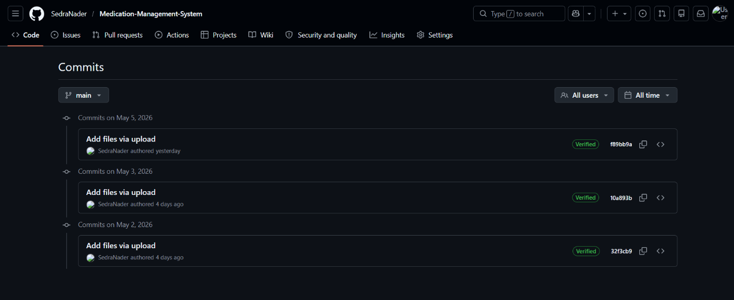
Each tag represents a stable snapshot of the system at a specific development stage and clearly documents architectural evolution.

Configuration Management System :

1. Introduction to Configuration Management
Configuration Management is a disciplined process used in software engineering to systematically manage, track, and control changes in a software system throughout its lifecycle.
Its main purpose is to ensure that:
• The system remains consistent and stable
• Changes are controlled and traceable
• Previous system states can be restored when needed
• Multiple versions of the system can coexist safely
In this project, Configuration Management was applied using Git-based version control, structured branching strategies, and formal version tagging.

2. Configuration Items (CIs)
A Configuration Item (CI) is any component of the system that is placed under configuration control.
In the Intelligent Medication Management project, the following were treated as configuration items:
• Source code files
• API controllers
• Domain models (Medication, Metadata)
• OCR processing logic
• Application configuration files (appsettings.json)
• Project structure and architecture
• Microservice boundaries
Each change to these items was tracked through Git commits.

The system consists of two main Configuration Items:
1. MedicationManagementSystem
  - Represents the core medication management and alerting system.
  - Responsible for prescription management, medication metadata storage, user authentication, and dosage alerting orchestration.
2. Medication.OcrService
  - Represents an independent OCR microservice.
  - Responsible only for processing prescription images and text extraction for medication details.
  - Can be developed, tested, and deployed independently from the main system.
Each project is versioned and managed as a separate configuration item within the same solution.

3. Configuration Identification
Configuration Identification defines what is controlled and how it is uniquely identified.
In this project, identification was achieved through:
• Git commits (unique commit hashes)
• Branch names representing development goals
• feature/ocr-integration
• feature/ocr-microservice
• Medication_FrontEnd – Frontend user interface development and integration
Each tag uniquely identifies a stable configuration of the system.

4. Configuration Control
Configuration Control ensures that changes are introduced in a controlled and approved manner.
This was implemented through:
• Feature branches for isolated development
• Pull Requests (PRs) for controlled merging
• Code review before merging into main
• Prevention of direct unstable changes to the main branch

5. Configuration Status Accounting
Configuration Status Accounting is the process of recording and reporting the state of configuration items over time.
In this project, this was achieved by:
• Git commit history
• Pull Request history
• Tag history showing system evolution
• Branch comparison (before and after refactor)

6. Configuration Auditing
Configuration Auditing verifies that:
• Changes were properly implemented
• The system matches its documented configuration
• No unauthorized changes exist
In the project:
• Pull Requests acted as configuration audits
• Merged code was verified to work correctly
• OCR refactor did not break existing functionality
• Tags marked only stable, verified versions

7. Configuration Management Applied to Architectural Evolution
A key Configuration Management activity in this project was managing architectural evolution.
The transition from:
• Monolithic OCR integration
to Independent OCR microservice
was handled as a controlled configuration change.
Using branching, versioning, and tagging allowed:
• Safe experimentation
• Rollback if needed
• Clear documentation of architectural decisions

Conclusion
Configuration Management in the Intelligent Medication Management project ensured that system changes were controlled, traceable, and reversible. By combining Git version control, structured branching, Pull Requests, and version tagging, the project successfully managed a major architectural refactor without disrupting system stability.

5. Summary:
Effective project management is a fundamental pillar for developing successful software systems. It ensures that projects are completed within scope and schedule, while considering available resources. Strong project management also supports the delivery of high-quality software services that offer innovative solutions, achieve objectives, and meet stakeholder expectations. In this way, solid management bridges ambitious ideas with tangible results.

chapter3

Fundamental Concepts and Literature Review

1. Introduction
This chapter provides an overview of the fundamental concepts and core technologies utilized in the development of the Intelligent Medication Management and Dosage Alert System. Understanding these concepts is essential for grasping the system's architecture, the logic behind medication tracking, and the integration of advanced features such as Optical Character Recognition (OCR) and drug interaction detection.

2. Software Architecture Patterns
The system is built using modern architectural patterns to ensure scalability, maintainability, and clear separation of concerns.

2.1 Microservices Architecture
A microservices architecture was adopted to decouple independent functional units. Specifically, the OCR Service operates as a standalone microservice. This allows the core medication management logic to remain lightweight while the computationally intensive image processing tasks are handled independently.
• Key Benefit: Independent deployment and scaling of the OCR engine without affecting the physician or patient portals.

2.2 Client-Server Model
The project follows a standard client-server model where the Frontend (User Interface) communicates with the Backend (API) through secure HTTP requests. This structure supports the dual-interface requirements for doctors and patients.

2.3 Repository Pattern
The Repository Pattern was implemented to create an abstraction layer between the data access layer and the business logic layer of the application.
• Decoupling: It ensures that the medication management logic does not depend directly on the database implementation (SQL).
• Centralized Logic: Provides a central place to manage data access logic, making it easier to maintain and test, especially for sensitive patient records and prescription data.

2.4 Middleware and Request Pipeline
Middleware components are utilized to handle cross-cutting concerns during the HTTP request lifecycle. In this project, middleware is responsible for:
• Authentication & Authorization: Ensuring that only authorized doctors can prescribe medications and only patients can access their personal dosage schedules.
• Error Handling: A global exception handling middleware is implemented to provide consistent error responses across the system, improving the reliability of the Medication Management API.
• Logging: Tracking system activities and drug interaction checks for auditing purposes.

2.5 Dependency Injection (DI)
Dependency Injection is a core technique used to achieve Inversion of Control (IoC) between classes and their dependencies.
• Enhanced Testability: Allows for easy mocking of services, such as the OCR service or the notification engine, during unit testing.
• Flexibility: Simplifies the process of swapping implementations (e.g., changing the database provider or the SMS/Email alert provider) without modifying the core business code.

3. Literature Review:
The purpose of this section is to analyze and evaluate various medication management and dosage reminder systems. This review aims to provide a comprehensive overview of existing platforms in the field, drawing insights from well-known solutions where available. By understanding current trends and identifying similarities and differences, the study helps inform the development of the proposed system, Intelligent Medication Management.

• Medisafe
An industry-leading mobile application and digital platform designed to help patients manage their medications and improve adherence.

Advantages:
• Comprehensive Dosage Tracking: Allows users to log various types of medications, including pills, injections, and liquids.
• Family Syncing: Enables caregivers to monitor the medication adherence of family members in real-time.
• Refill Reminders: Notifies users when their medication stock is running low based on the doses taken.
• Drug Interaction Warnings: Provides basic alerts for potential interactions between added medications.
• Health Reports: Generates visual adherence reports that can be shared with healthcare providers.

Disadvantages:
• Privacy Concerns: Being a cloud-based commercial app, users may have concerns regarding the secondary use of their health data.
• Manual Data Entry: Most versions require users to manually input medication details, which can lead to errors.
• Feature Overload: The interface can be cluttered with non-essential features (e.g., coupons, advertisements), making it difficult for elderly users to navigate.
• Dependency on Connectivity: Many advanced syncing and database features require a continuous internet connection.
Core Features:
• Personalized Dosage Schedules.
• Persistent Visual and Audio Alerts.
• Medication Inventory Management.
• Caregiver/Medfriend Notifications.

• Open-Source Medication Tracker (Generic Framework)
A free and open-source platform suitable for small to medium-sized healthcare clinics and independent medical practices.

Advantages:
• Fully Open-Source: Licensed under GPL, allowing for complete customization of the medication alert logic.
• OCR Integration: Capable of integrating with engines like Tesseract for medication label extraction.
• Advanced Search: Supports full-text search across extensive patient prescription histories.
• Version Control and Audit Trail: Maintains a detailed history of all changes made to a patient’s treatment plan.
• Fine-Grained Role-Based Access Control: Highly secure management of permissions for doctors, nurses, and caregivers.
• Modular and Extensible Architecture: Easily allows for the addition of new features like drug-interaction APIs.

Disadvantages:
• Technical Setup: Installation and configuration require advanced technical knowledge of server environments.
• User Interface: Often features a less intuitive or more complex UI compared to commercial mobile apps.
• No Built-in Semantic Search: Lacks advanced AI-driven search capabilities for medical symptoms or interactions out-of-the-box.
• Manual Maintenance: Requires regular manual updates and security patches by a dedicated IT team.
• Resource-Intensive: Can be demanding on hardware resources when managing large-scale medical records.

Core Features:
OCR for Label Recognition, Comprehensive Medication Metadata, Full-text History Search, Versioning of Prescriptions, Automated Alert Workflow, API Integration for Drug Data.

• Open-Source Medication Tracker (Generic Framework)
A free and open-source platform suitable for small to medium-sized healthcare clinics and independent medical practices.

Advantages:
• Fully Open-Source: Licensed under GPL, allowing for complete customization of the medication alert logic.
• OCR Integration: Capable of integrating with engines like Tesseract for medication label extraction.
• Advanced Search: Supports full-text search across extensive patient prescription histories.
• Version Control and Audit Trail: Maintains a detailed history of all changes made to a patient’s treatment plan.
• Fine-Grained Role-Based Access Control: Highly secure management of permissions for doctors, nurses, and caregivers.
• Modular and Extensible Architecture: Easily allows for the addition of new features like drug-interaction APIs.

Disadvantages:
• Technical Setup: Installation and configuration require advanced technical knowledge of server environments.
• User Interface: Often features a less intuitive or more complex UI compared to commercial mobile apps.
• No Built-in Semantic Search: Lacks advanced AI-driven search capabilities for medical symptoms or interactions out-of-the-box.
• Manual Maintenance: Requires regular manual updates and security patches by a dedicated IT team.
• Resource-Intensive: Can be demanding on hardware resources when managing large-scale medical records.

Core Features:
OCR for Label Recognition, Comprehensive Medication Metadata, Full-text History Search, Versioning of Prescriptions, Automated Alert Workflow, API Integration for Drug Data.

3.2 Comparative Analysis of Reviewed Systems
After reviewing several medication management platforms, it is evident that while existing solutions like Medisafe and various Open-Source Trackers offer robust features, they cater to different primary targets. Medisafe is highly optimized for individual patient use with a focus on a user-friendly mobile experience and family syncing. However, it often remains a "siloed" application, meaning the link between the patient’s daily adherence and the physician's real-time monitoring is not always seamless.

On the other hand, Open-Source Trackers provide a high degree of privacy and customization, making them suitable for clinical environments. Yet, they require significant technical expertise to manage and often lack the proactive "Intelligent Alert" mechanisms necessary for high-risk medication schedules.

The proposed system, Intelligent Medication Management, bridges these gaps by integrating the strengths of both approaches. It provides the ease of use found in commercial apps for patients, while offering the robust data management and role-based access control required by healthcare professionals.

4. Conclusion of Literature Review
The analysis of existing literature and current market solutions highlights a critical need for a more integrated approach to medical adherence. Most systems focus either on the patient or the doctor, but rarely on the dynamic interaction between them.

The Intelligent Medication Management system is designed to address this by introducing a dual-interface architecture. By incorporating intelligent, persistent alert mechanisms, real-time inventory tracking, and dedicated portals for clinical decision support, the system provides a holistic and safer environment for managing complex treatment plans. This approach ensures that medication adherence is not just tracked, but actively managed to prevent human error and optimize therapeutic outcomes.

5. Tools and Technologies
To achieve the objectives of the Intelligent Medication Management system, a selection of modern programming languages, frameworks, and development tools were employed. These tools were chosen based on their efficiency, community support, and suitability for medical data processing.

5.1 System Development Technologies
The application architecture is built utilizing modern web technologies aligned with the core system requirements. For the frontend development, React.js is employed alongside standard HTML5, CSS3, and JavaScript to construct dynamic, responsive user dashboards for patients, doctors, and system managers. The backend business logic is powered by Node.js and Express.js, providing an asynchronous, event-driven architecture that efficiently handles RESTful API integration, automated dosage schedule constraints, and quick notification distributions.

5.2 Database Management Architecture
To ensure continuous data persistence and reliable medical logging, a structured MySQL relational database is implemented. This data layer effectively maps and stores comprehensive system entities, including secure user credentials, authorized medical prescription tracking files, complete pharmaceutical inventory statistics, and temporal patient adherence logs, maintaining strong relational integrity across all operational tables.• Visual Studio Code (VS Code): The main Integrated Development Environment (IDE) used for writing and debugging the system’s code.

Summary
The Intelligent Medication Management and Dosage Alert System is designed to digitize patient prescriptions and treatment plans using OCR and structured metadata, ensuring secure access and high treatment adherence through automated alert mechanisms.

From the literature review, Medisafe and various Open-Source Trackers were identified as relevant systems in terms of medication tracking and role-based functionalities. While Medisafe provides an excellent user experience for personal adherence, the Open-Source solutions offer greater flexibility and data privacy for clinical settings.

This analysis highlights the strengths and limitations of existing platforms, guiding the development of the Intelligent Medication Management system as a secure, efficient, and integrated solution tailored to the needs of both patients and physicians without the limitations of fragmented commercial platforms.

Below is a summary of the key services offered by the proposed Intelligent Medication Management System.

Table 3.1: A brief analysis of similar systems and the target system.
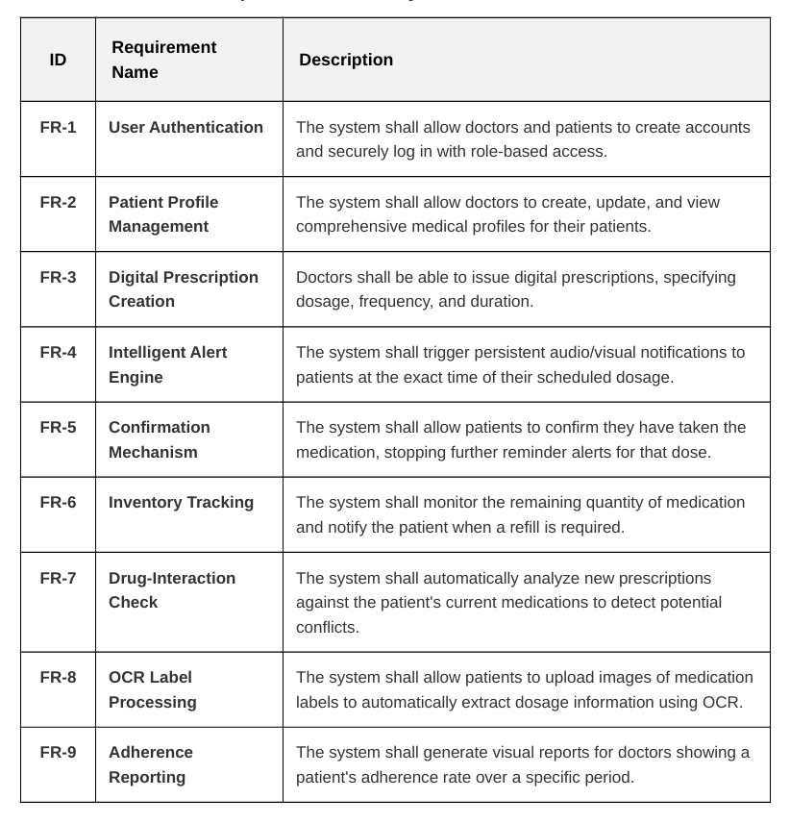

chapter4

System Analysis

1. Introduction
This chapter focuses on the detailed analysis of the Intelligent Medication Management and Dosage Alert System. The main objective is to study the needs of patients and healthcare providers, helping to identify the essential requirements and core functionalities that the proposed system must include. The chapter explores mechanisms for digital prescription management, real-time dosage alerts, and inventory tracking, along with a comprehensive analysis of use cases and workflows. This provides a clear understanding of how users interact with the system and how their health management goals can be achieved through it.

2. Software Requirement Specification (SRS):
The Software Requirement Specification is a fundamental document in the development process of the Intelligent Medication Management System. It is used to describe the functional and non-functional requirements of the proposed system in a clear and structured manner.

The specification includes the following key elements:
1. System Description: The system aims to digitize, organize, and manage medical prescriptions within a secure environment, supporting intelligent alerts, drug interaction checks, and inventory tracking.
2. Inputs and Outputs: Inputs include patient health data, digital prescriptions, and medication label images (via OCR), while outputs consist of real-time dosage alerts, adherence reports for doctors, and refill notifications.
3. Performance Requirements: The system must process dosage alerts and medication checks efficiently, supporting a high number of concurrent users without delays in notification delivery.
4. Interface Requirements: The system should provide intuitive interfaces for both doctors and patients, ensuring easy navigation for prescription entry and dosage confirmation.
5. Security Requirements: The system must offer robust access control mechanisms, data encryption for patient records, and activity logging to ensure medical data integrity.
6. Maintenance Requirements: The system should be upgradable and extensible, allowing for future enhancements such as integration with wearable health devices without compromising core performance.

The SRS document facilitates effective communication between the development team and stakeholders, ensuring a shared understanding of the system’s requirements. It also serves as a reference throughout the development process to verify that all specifications are properly implemented, contributing to the system’s success and medical safety.

3. Software Requirement Specification (SRS)
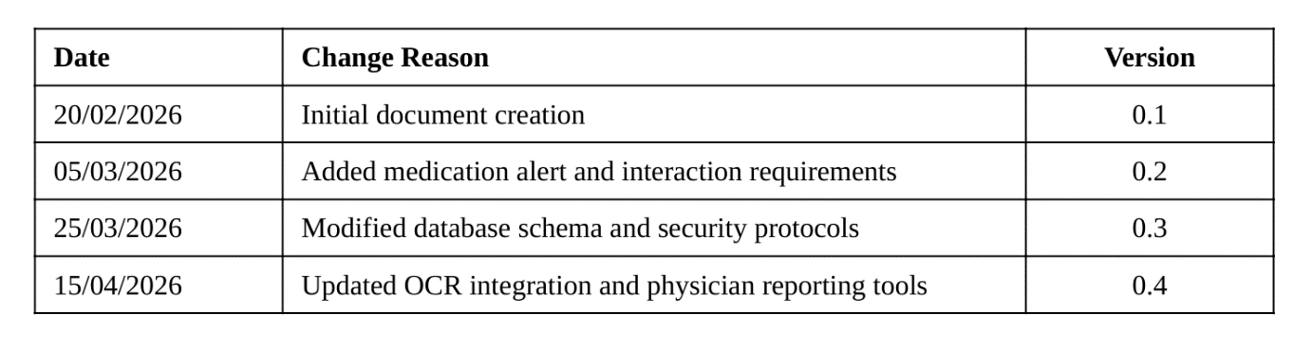

1. Introduction
The Software Requirement Specification (SRS) document serves as a formal agreement between the development team and stakeholders. It provides a clear and detailed description of the system's functional and non-functional requirements, ensuring that all project goals are aligned. This document is essential for maintaining consistency during the development phases of the Intelligent Medication Management and Dosage Alert System, acting as a baseline for validation and quality assurance.

1.1 Purpose
The main purpose of this document is to specify the technical and operational requirements for the Intelligent Medication Management System. This platform is designed to assist both physicians and patients by digitizing prescriptions, providing real-time dosage alerts, and analyzing potential drug interactions. By defining these requirements clearly, the document ensures that the final product meets the clinical safety standards and user expectations for effective medication adherence.

1.2 Project Scope
The scope of the Intelligent Medication Management System covers the development of a secure, integrated platform that bridges the gap between medical prescriptions and daily patient intake. Key features within this scope include an OCR-based medication label reader, a centralized patient database for physicians, and an intelligent notification engine for patients. The system is designed to be scalable, supporting future integrations with pharmacy databases and wearable health tracking devices.

1.2.1 High-Level Requirements
• Account Management: This function allows users (doctors and patients) to log in using email or username and password, securely log out, and supports multi-factor authentication for sensitive medical data protection.
• User Role Management: The system enables the creation of specific roles (System Admin, Doctor, Patient), defining what each role can perform regarding prescription entry, medical history access, and alert configurations.
• Prescription Management: Doctors can upload or create digital prescriptions, edit medication metadata (dosage, frequency), and archive past treatment plans based on permissions.
• Medication Label Extraction: The system automatically performs OCR to extract dosage and timing information from medication label images, supporting both Arabic and English with automatic language detection.
• Intelligent Alert Engine: The system applies specialized notification algorithms to trigger real-time audio and visual alerts for scheduled doses, ensuring patient adherence.
• Drug Interaction Management: The system extracts key ingredients from new prescriptions and automatically checks them against the patient's existing medication list to detect and warn about potential interactions.
• Search and Navigation: The system provides full-text search for medications and patients, along with filter-based search (by date, doctor, or medication type) for quick access to records.
• Inventory Lifecycle Management: The system monitors the quantity of medication remaining and supports various states (Active, Refill Needed, Completed, Expired) with secure tracking before a prescription is fully consumed.

• Audit Logging: All user and doctor actions, such as prescription entries, dosage confirmations, and schedule modifications, are recorded to ensure transparency and treatment traceability.
• External System Integration: The system can securely share adherence reports with other healthcare platforms or insurance providers and supports data import/export in standard medical formats like JSON and XML.

1.2.2 Actors:
• Patient: The patient is the primary individual responsible for confirming medication intake within the system. They can upload images of medication labels, edit their personal profile, confirm or skip doses based on real-time alerts, and search for their past medication history using full-text or semantic tools. The patient can also track the status of their current prescriptions and download their adherence reports.
• Doctor: The doctor is a user with extended permissions, such as creating and reviewing digital prescriptions for their assigned patients. They can approve or modify medication schedules, manage patient-specific alerts, and access detailed adherence activity reports and logs. Doctors can also adjust medication details based on patient feedback or health progress.
• System Admin: The system administrator holds the highest level of access. They configure the overall system, create user roles and assign permissions, manage integration settings with medical databases, and monitor overall system performance. The admin also handles backup operations and ensures compliance with medical data security and reliability standards.

2. General Description

2.1 Product Perspective
The Intelligent Medication Management and Dosage Alert System described in this document is an intelligent and innovative solution that offers a range of benefits to both patients and healthcare providers. It provides a secure and flexible digital environment that enables users to manage prescriptions, receive automated alerts, and automatically extract medication data from images using OCR and artificial intelligence technologies.

2.2 Product Features
• Account Management:
Login and logout using email or username and password, with support for multi-factor authentication (MFA) to ensure the privacy of patient health records (for all users).
• Medication Management:
Upload digital prescriptions or medication label images, edit medication details (dosage, frequency), and archive past treatments based on permissions. Users can also download adherence reports or original prescription scans (for users).
• Intelligent Alert System:
Automatic generation of real-time audio and visual notifications based on prescribed schedules, ensuring timely medication intake and reducing the risk of missed doses (for patients).
• Label Data Extraction:
Apply intelligent OCR algorithms to automatically extract textual content (medication name, concentration, instructions) from images and PDFs, supporting both Arabic and English (for users).
• Drug Interaction Check:
Extract key chemical components from medications to identify potential interactions and suggest warnings or safety alerts for review by a healthcare professional (for doctors).
• Search and Navigation:
Full-text search within medication history and patient records, along with filter-based search (by date, doctor, or medication category) and result sorting by most recent (for users).

2.3.2 Doctor
• Responsibilities: Review medication data uploaded by patients, approve or modify dosage schedules, manage patient permissions within the clinic or hospital, and route prescriptions to the appropriate pharmacy sections if needed.
• Privileges: Approve and modify medication plans, adjust automated classifications, access patient adherence logs, and manage patient-specific alert configurations.

2.3.3 System Admin
• Responsibilities: The system administrator is responsible for the overall maintenance of the platform, including user account management, system configuration, and ensuring data security and integrity. They monitor system performance and handle database backups.
• Privileges: Full access to system settings, user role management, integration configuration with medical databases, and access to comprehensive audit logs for all system activities.

3. System Features

3.1 Functional Requirements

3.1.1 Account Management
• Requirement 1.1: The system allows users to log in using username or email and password.
• Requirement 1.2: The system allows users to log out securely.
• Requirement 1.3: The system supports multi-factor authentication (MFA) for patients and doctors to protect sensitive medical records.

3.1.2 Medication Management
• Requirement 2.1: The system allows users to upload digital prescriptions and medication label images in various formats (JPG, PNG, PDF).
• Requirement 2.2: The system allows doctors and patients to edit medication metadata, such as dosage, frequency, and medication name.
• Requirement 2.3: The system allows patients to confirm medication intake or skip a dose with a recorded reason.
• Requirement 2.4: The system allows doctors to archive completed treatment plans and access patient medication history.

• Requirement 2.5: The system allows users to download the original or OCR version of the medication label or prescription.
• Requirement 2.6: The system integrates with mobile cameras and scanning devices to import paper prescriptions directly.

3.1.3 Content Extraction
• Requirement 3.1: The system performs automatic OCR to extract text from medication label images and prescriptions.
• Requirement 3.2: The system supports Arabic and English with automatic language detection for medication labels.
• Requirement 3.3: The system extracts key metadata from the medication label such as medication name, dosage concentration, and expiration date.

3.1.4 Classification and Search
• Requirement 4.1: The system classifies medications by type (e.g., chronic, emergency, supplement) using intelligent algorithms.
• Requirement 4.2: The system suggests appropriate alert categories or scheduling folders for archiving medication history.
• Requirement 4.3: The system enables full-text search within prescription content.
• Requirement 4.4: The system enables semantic search for medications using artificial intelligence to understand user queries.
• Requirement 4.5: The system supports filter-based search (by medication type, date added, or prescribing doctor).

3.1.5 Medication Lifecycle Management
• Requirement 5.1: The system supports various medication states (Active, Refill Needed, Completed, Expired).
• Requirement 5.2: The system moves expired or discontinued prescriptions to a secure archive before permanent deletion.

3.1.6 Audit Logging
• Requirement 6.1: The system records all user actions, including dosage confirmations, alert modifications, and prescription uploads.

3.1.7 System Administration
• Requirement 7.1: The system allows the admin to create roles (Doctor, Patient) and assign specific permissions.
• Requirement 7.2: The system allows configuration of integration with external medical or pharmaceutical databases.
• Requirement 7.3: The system allows backup management of patient records and performance monitoring.

3.2 Non-Functional Requirements
• Scalability:
The system must be scalable to support an increasing number of patients and doctors without performance degradation.
• Security:
The system must ensure high data encryption for all medical records and provide secure access control.
• Reliability:
The alert engine must be highly reliable, ensuring that notifications are delivered at the exact scheduled time without failure.

• Multi-Language Support:
The system must support adding new languages (such as French or German) easily without deep structural changes to the database or UI.
• Availability:
The system must maintain operational readiness to provide continuous medication management and alert services 24/7.
• Security:
• Medical data must be encrypted during transmission and storage to ensure patient privacy.
• Passwords and sensitive health information must be stored securely using industry-standard encryption.
• Usability:
The user interface must be simple, responsive, and easy to understand for all user categories, especially patients who may not be tech-savvy.
• Maintainability:
• The code must be modular and well-documented to allow for future updates by different development teams.
• The system must support future updates, such as adding new drug interaction databases, without affecting core functionalities.

4. System Requirements
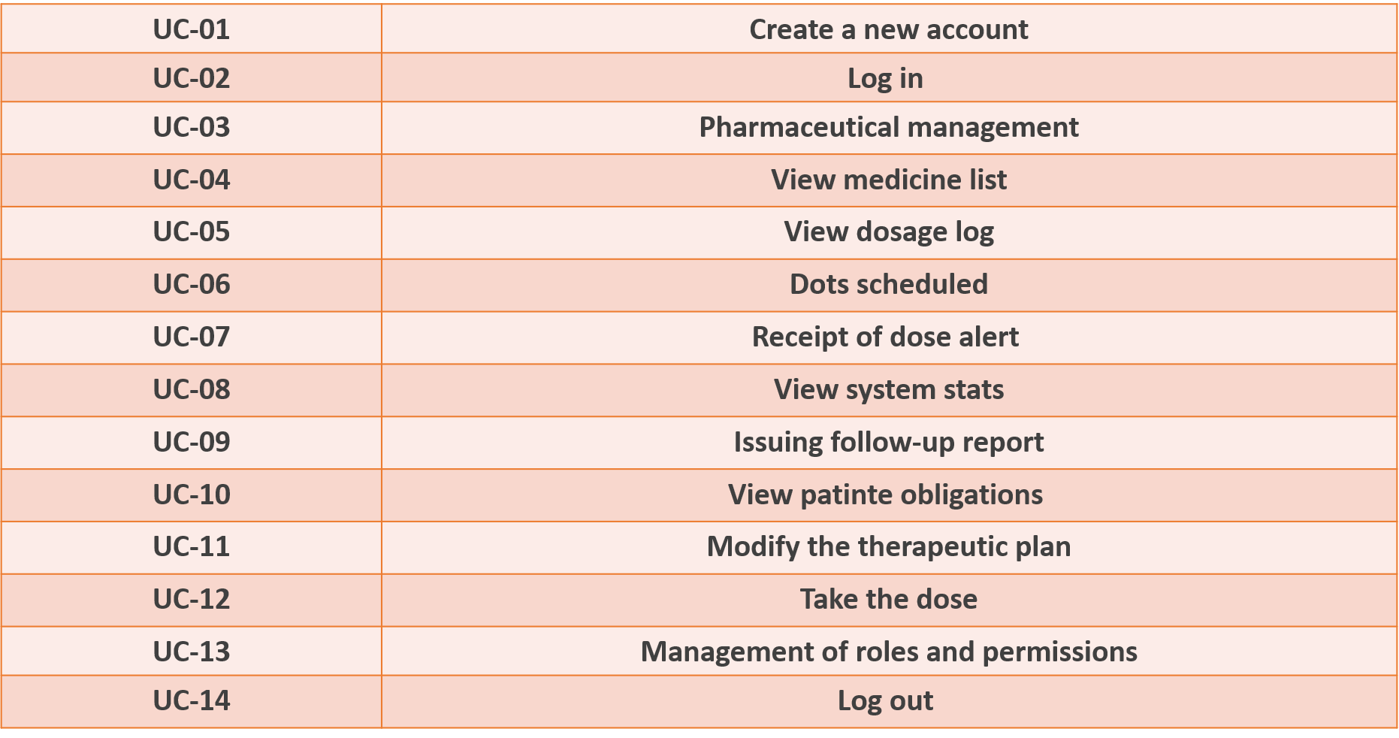

5.Use Case Diagram

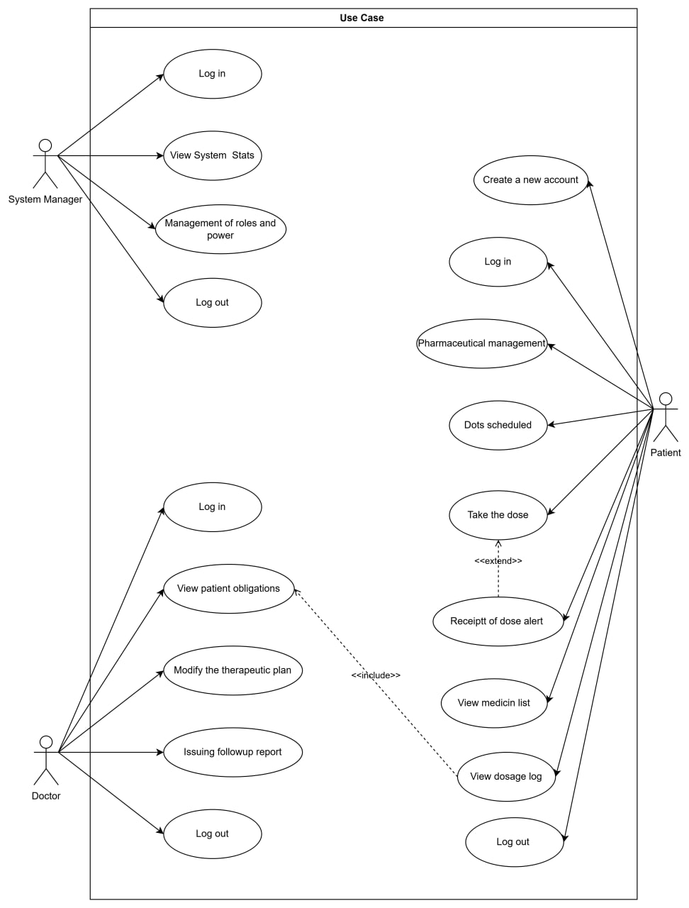

5.2System Features _ Use Case Description
- login ( UC-01 ) - use case specification :
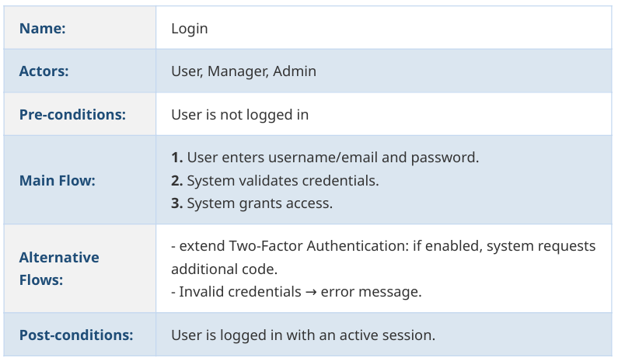

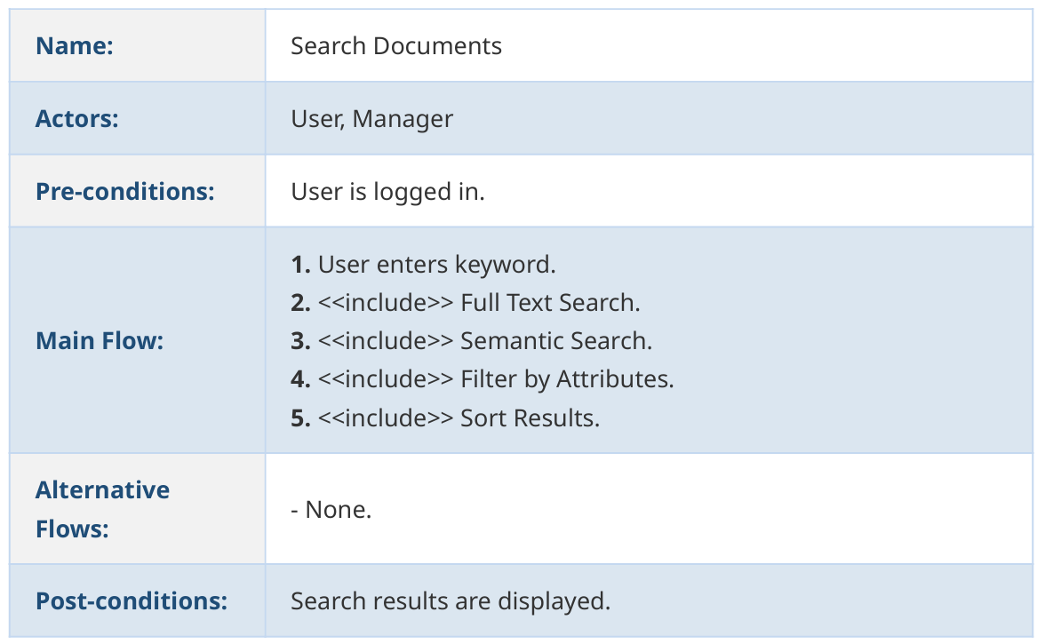
- Search Documents ( UC-02 ) - use case specification :

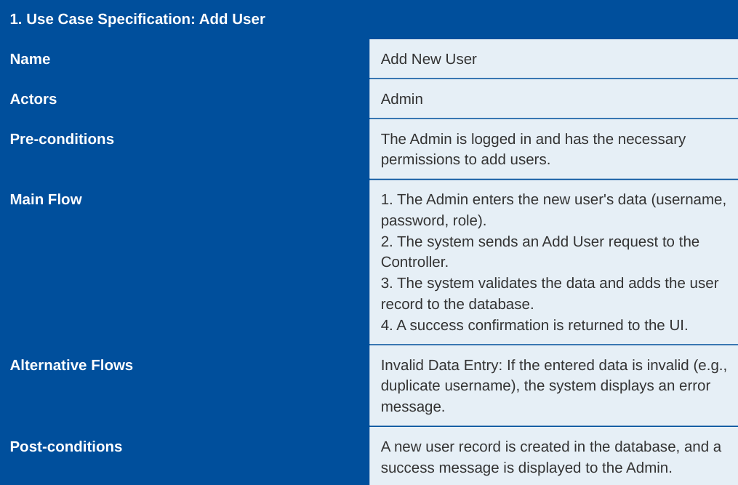
- Add User ( UC-03 ) - use case specification :

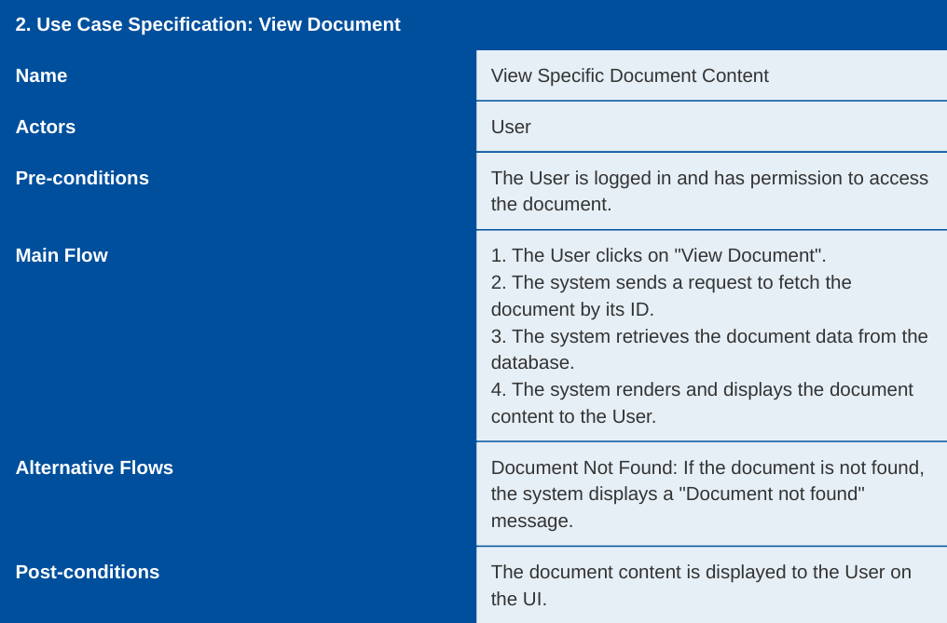
- View Document ( UC-04 ) - use case specification :

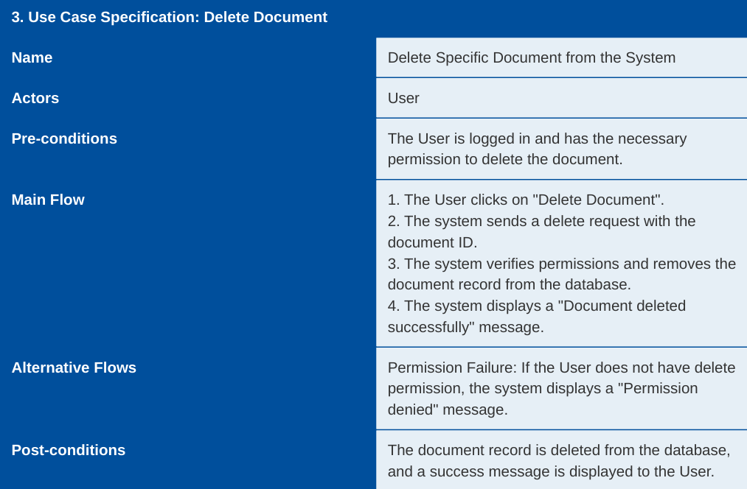
- Delete Document ( UC-05 ) - use case specification :

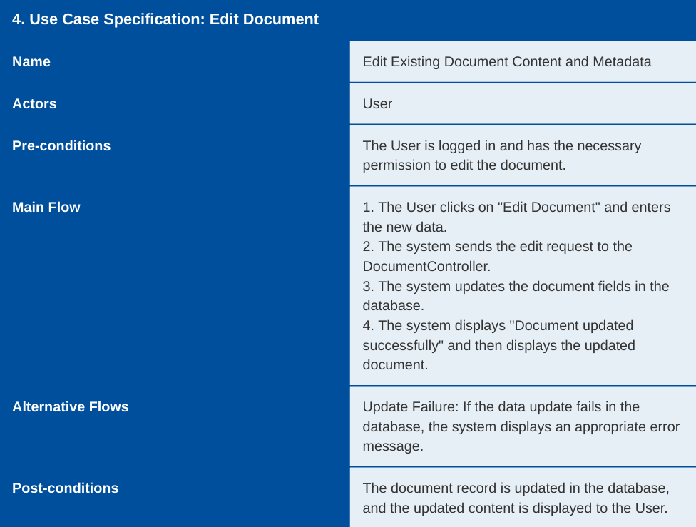
- Edit Document ( UC-06 ) - use case specification :

- Check Permissions ( UC-07 ) - use case specification :
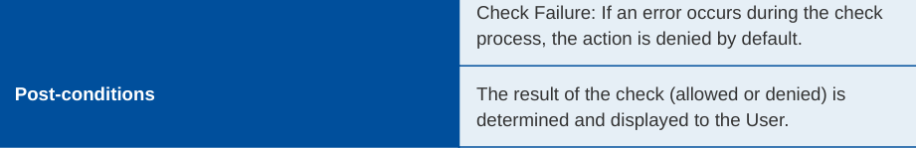
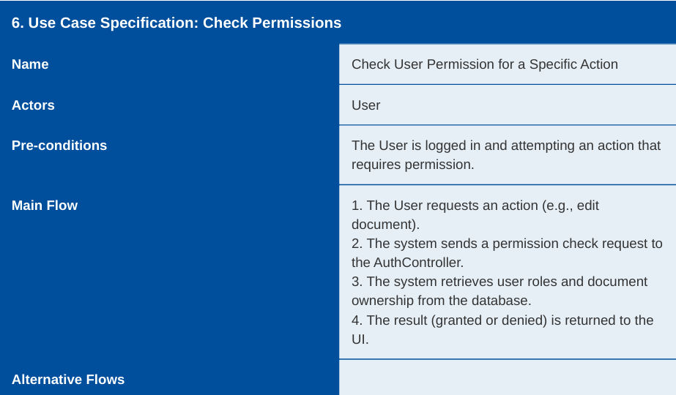

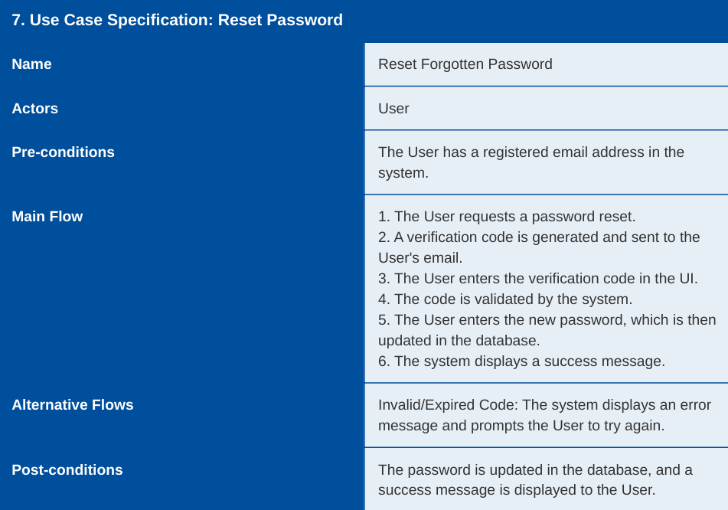
- Reset Password ( UC-08 ) - use case specification :

- Upload Document ( UC-09 ) - use case specification :
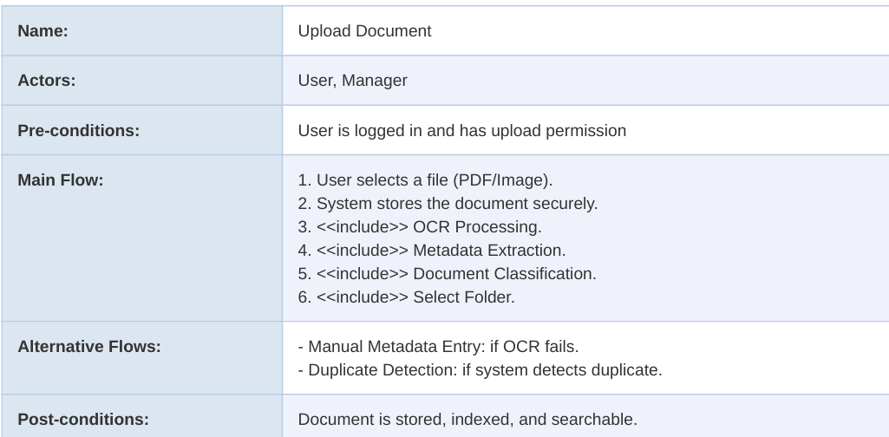

- Generate Reports ( UC-10 ) - use case specification :
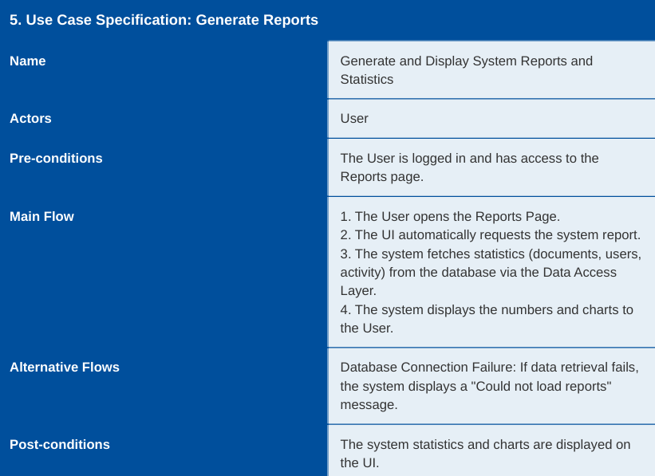

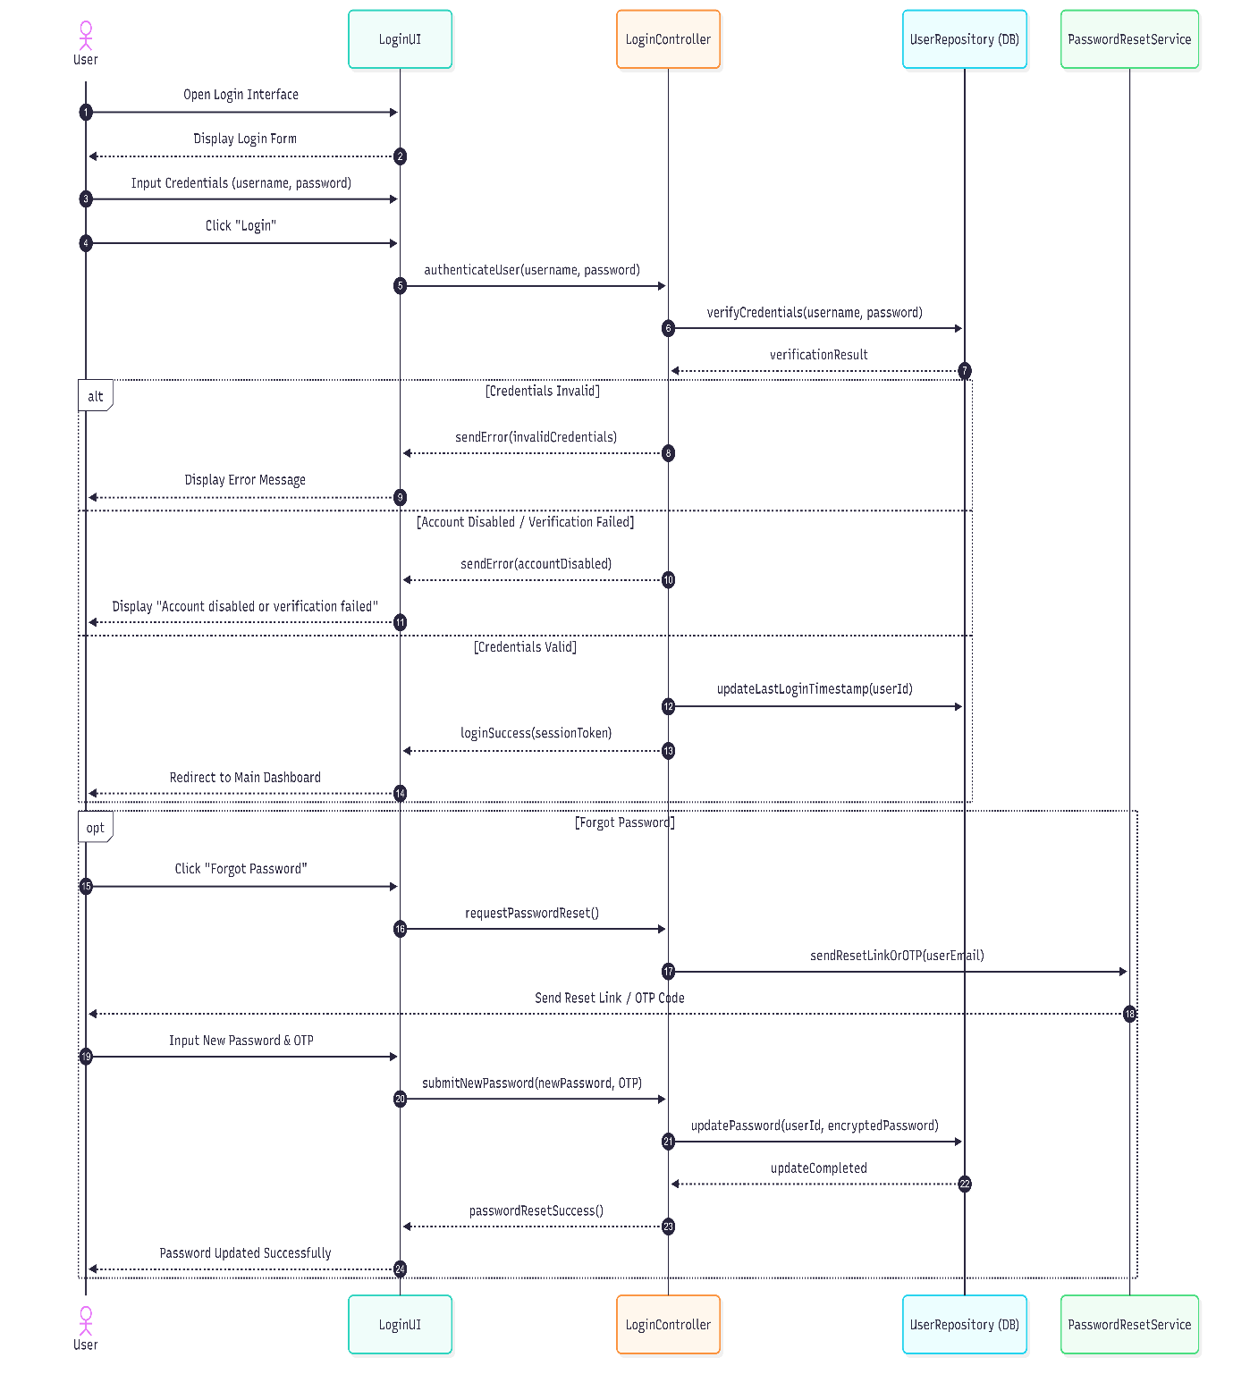
5.3 Sequence Diagram:
تسجيل الدخول الى النظام

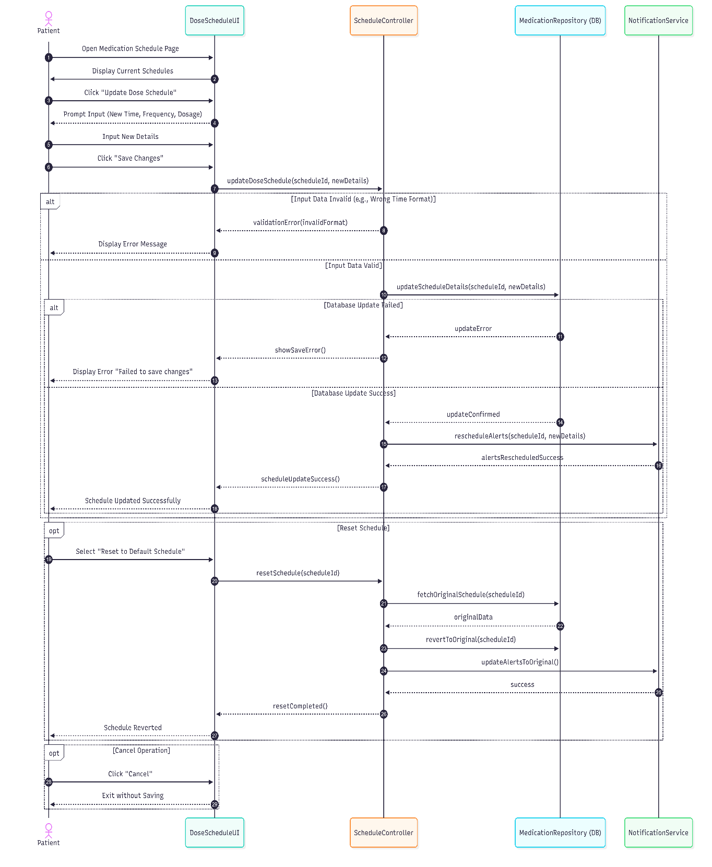
تحديد مواعيد الجرعات

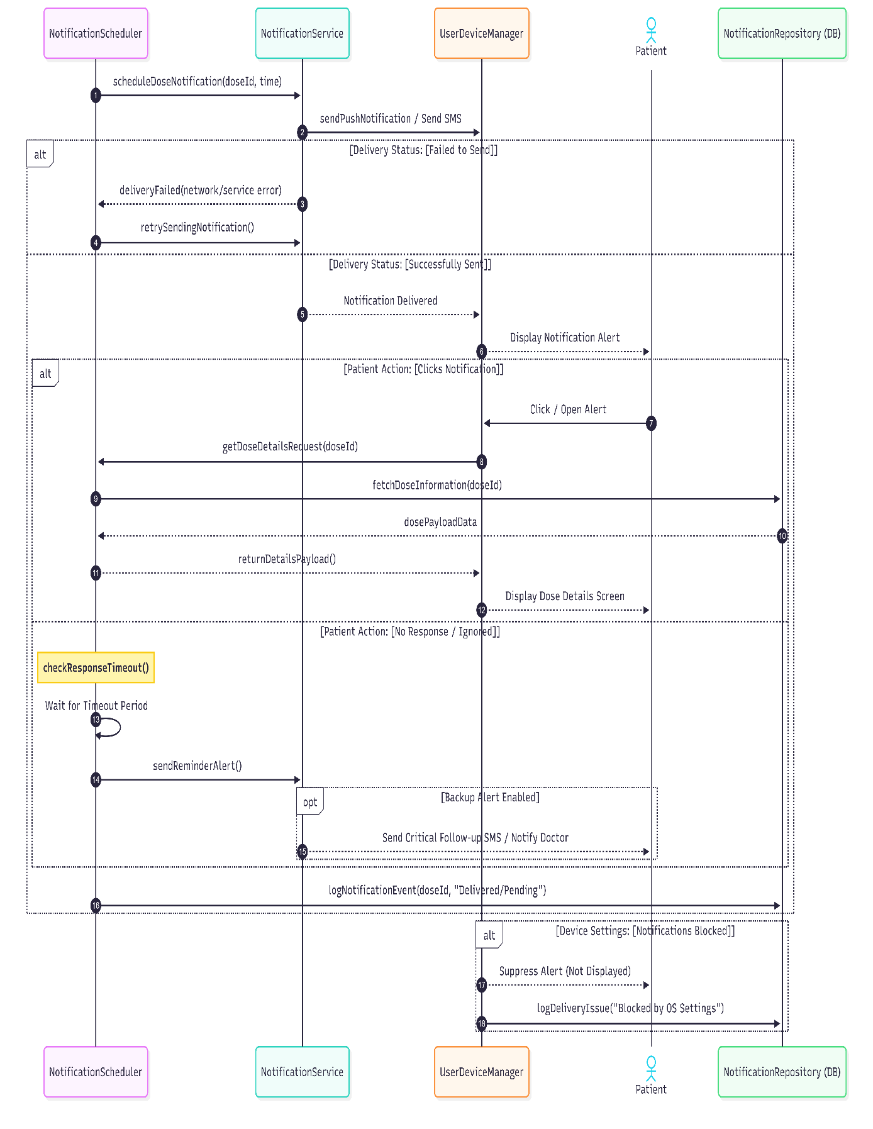
استلام تنبيه الجرعة

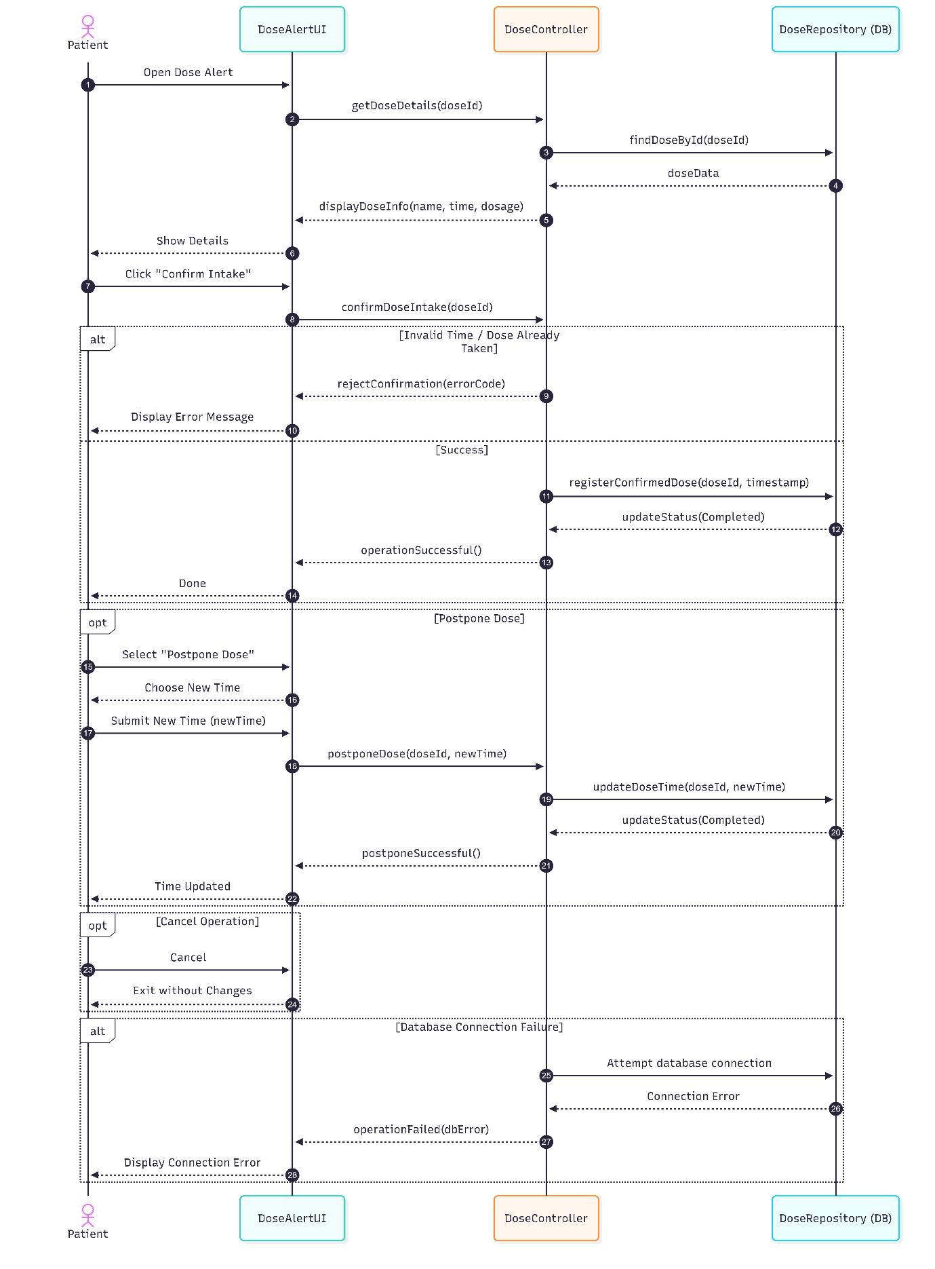
تأكيد تناول الجرعة
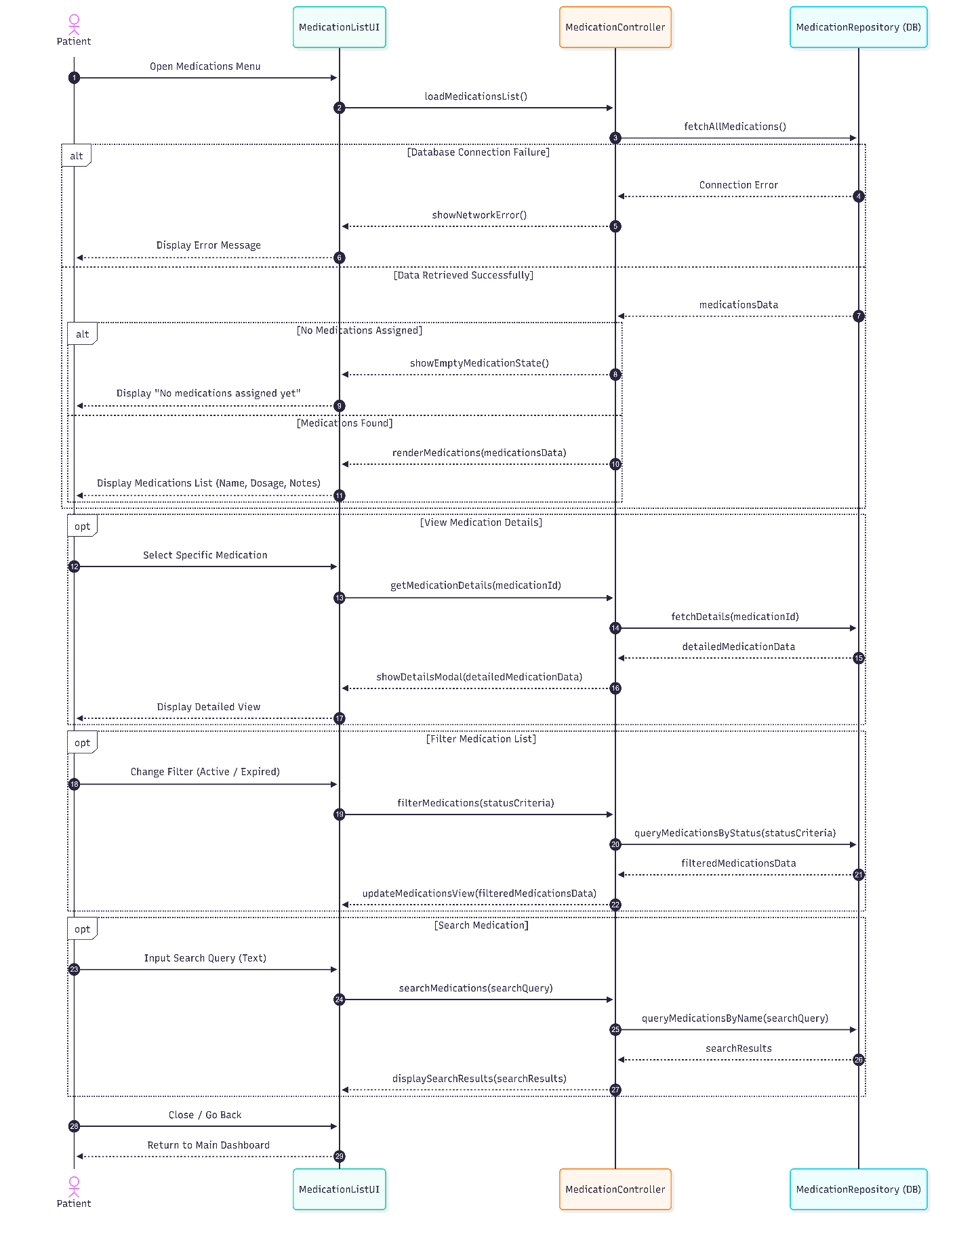عرض قائمة الادوية
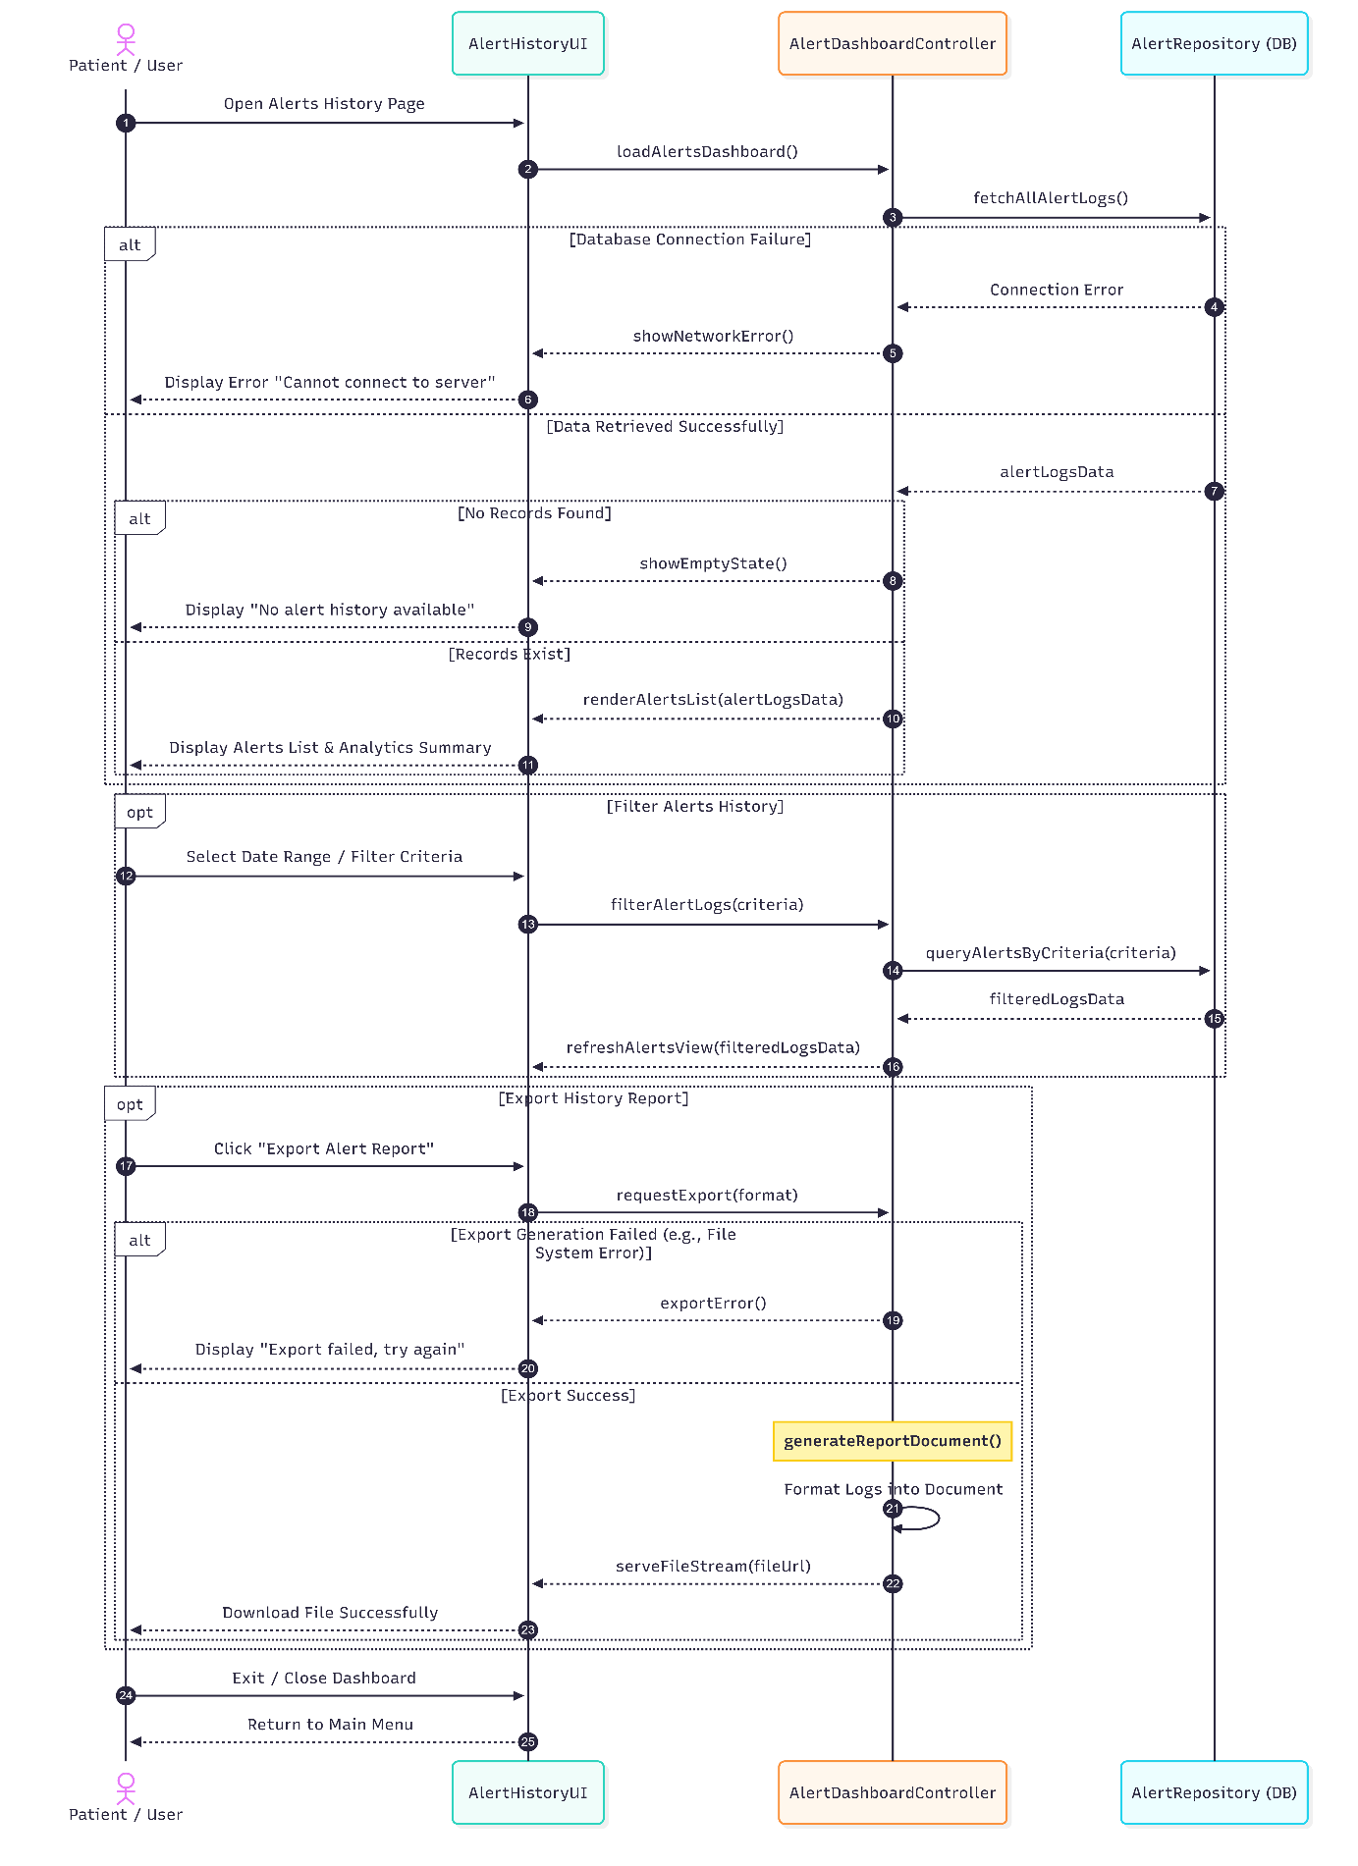
عرض سجل الجرعات

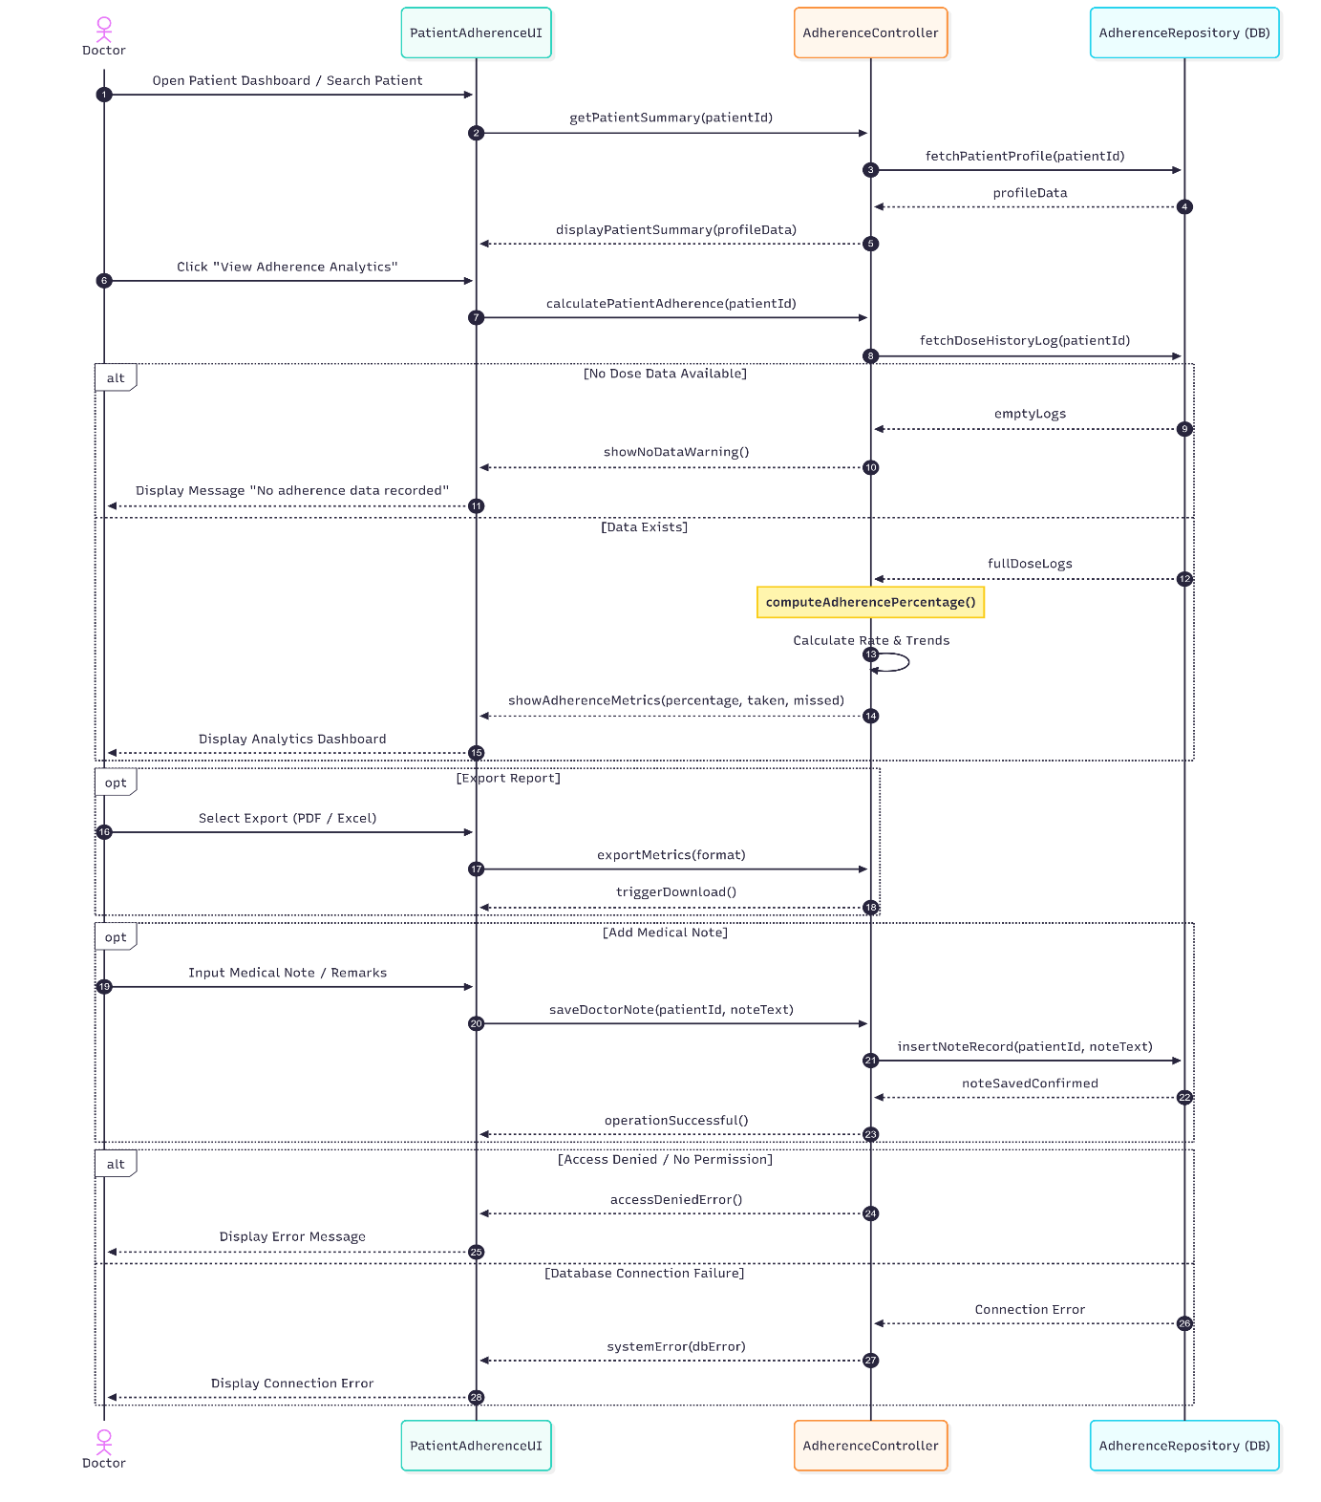
عرض التزام المريض

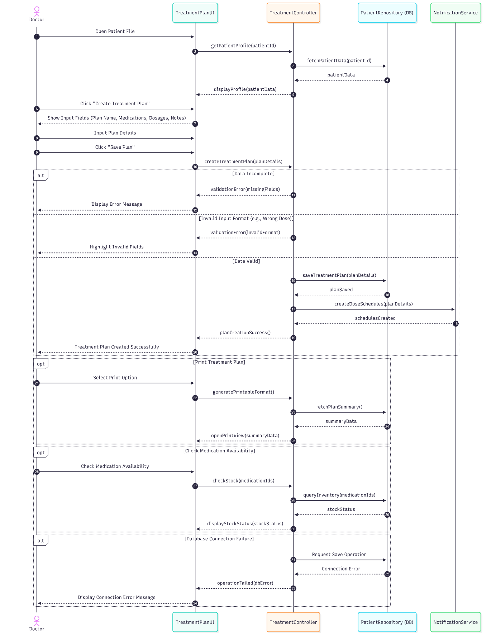
تعديل الخطة العلاجية

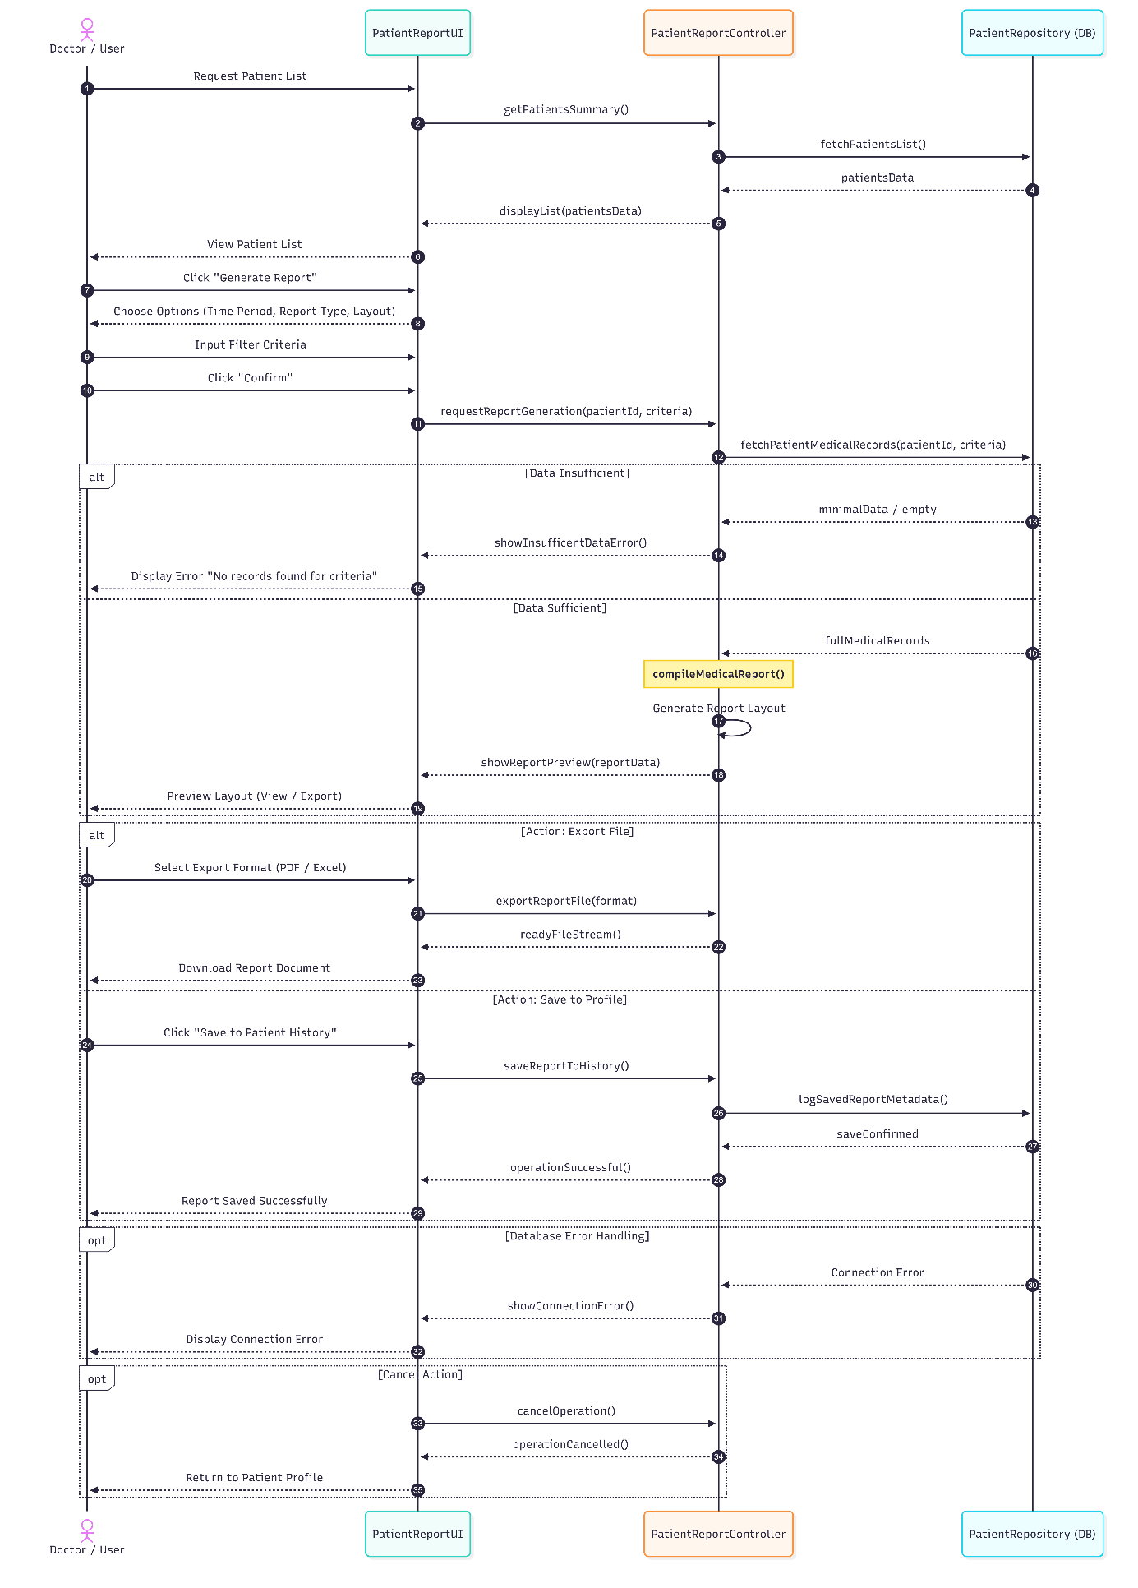
إصدار تقرير المتابعة

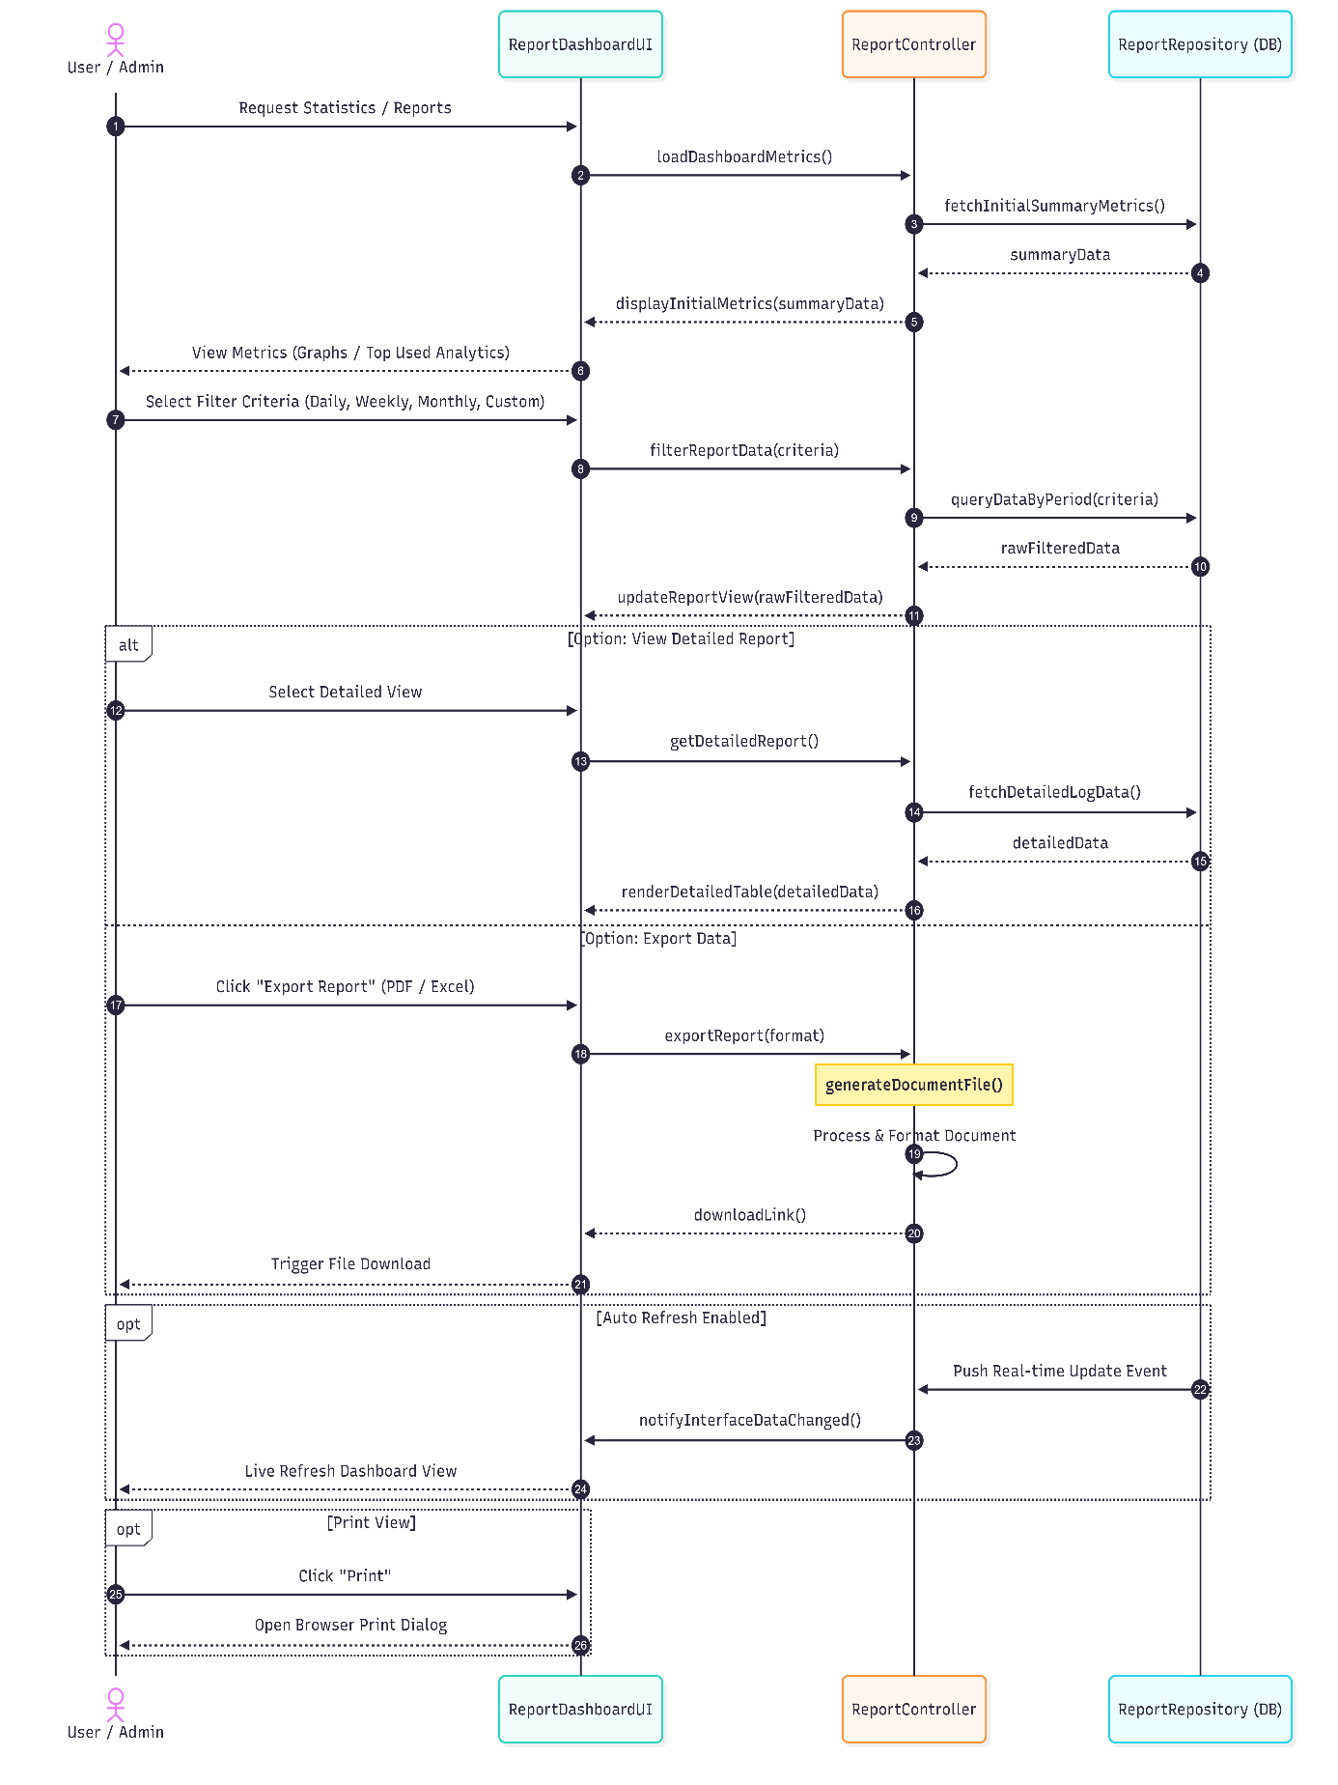
عرض إحصائيات النظام

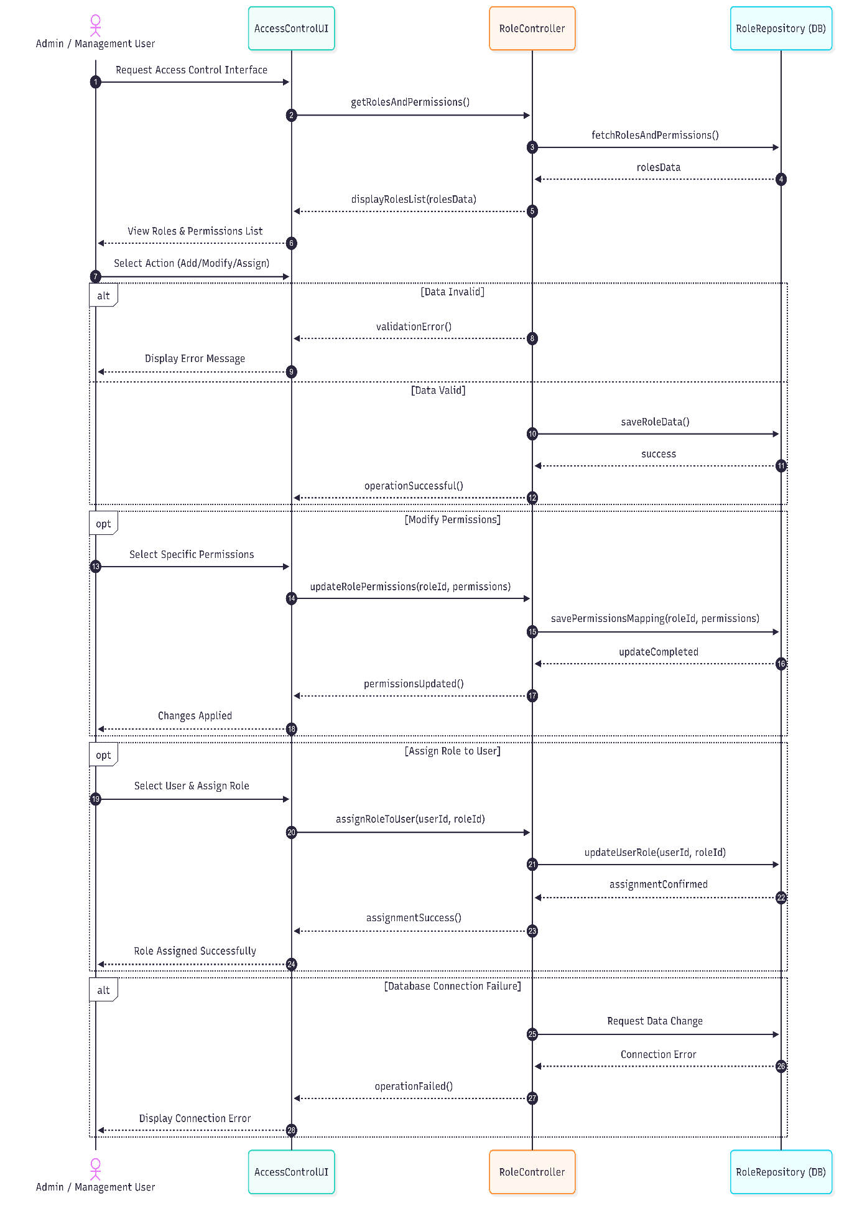
إدارة الأدوار والصلاحيات

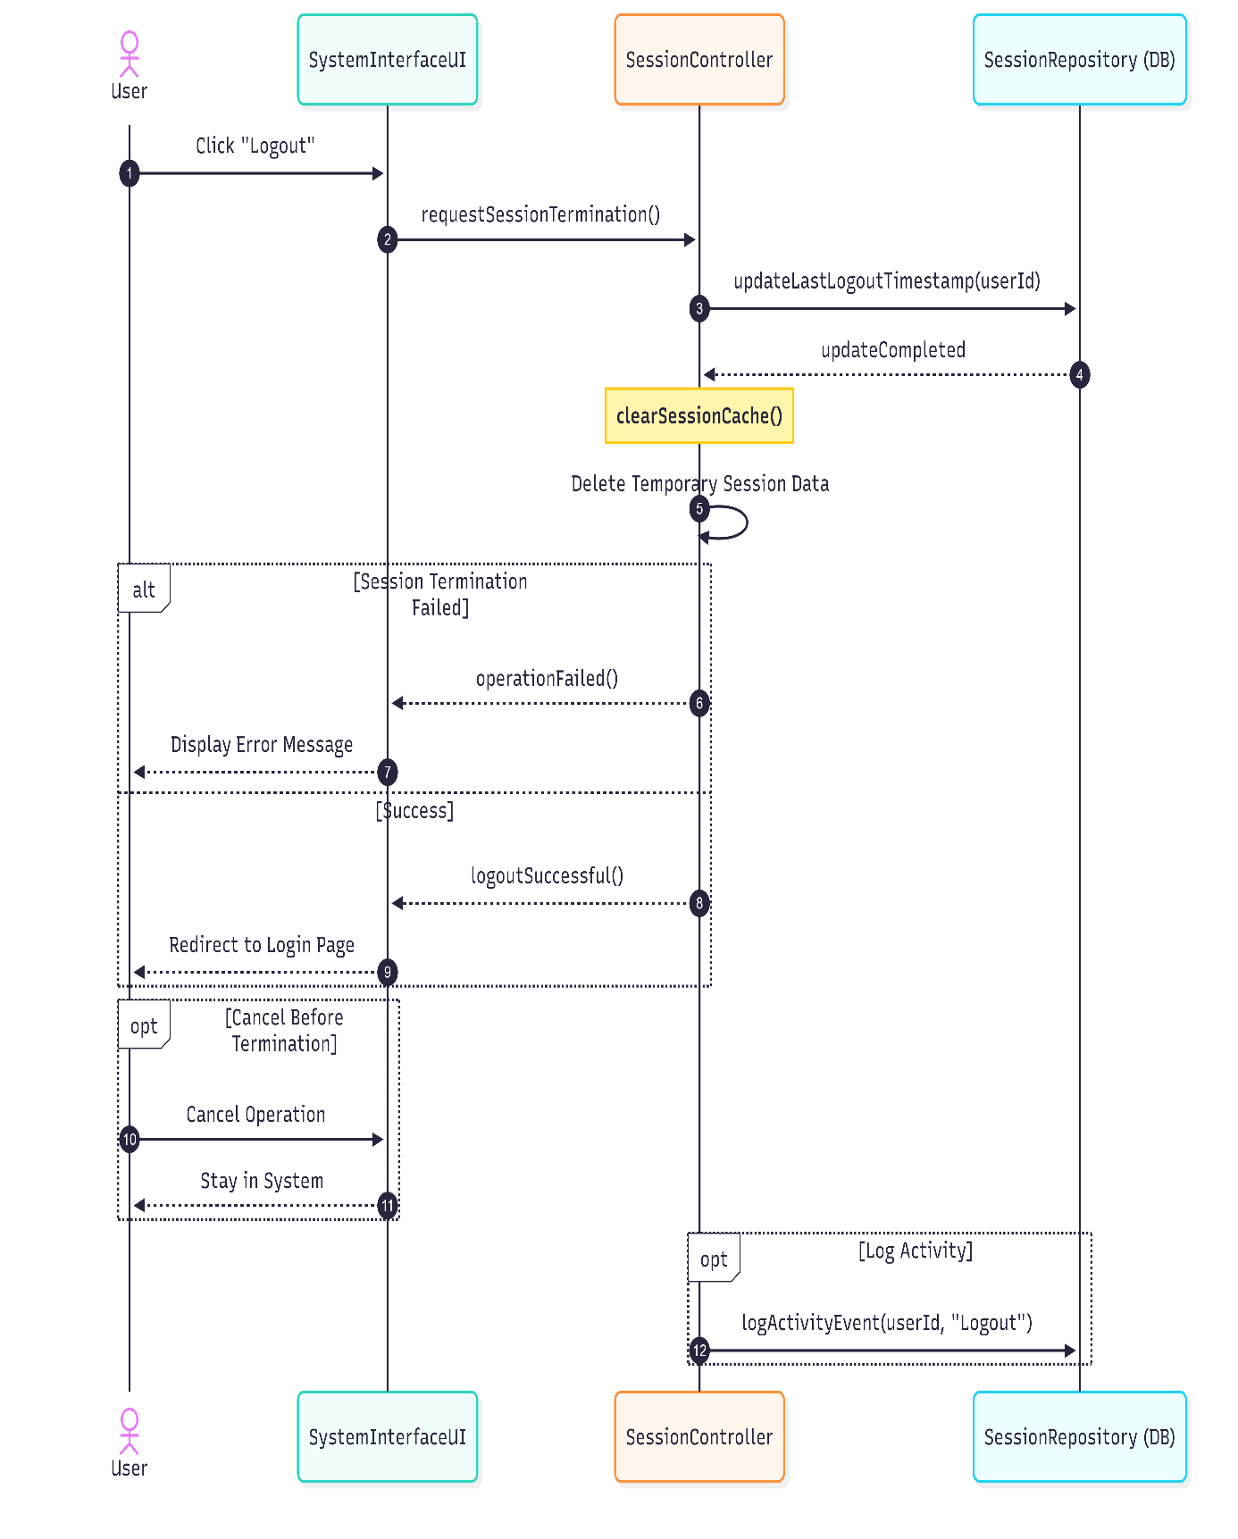
تسجيل الخروج

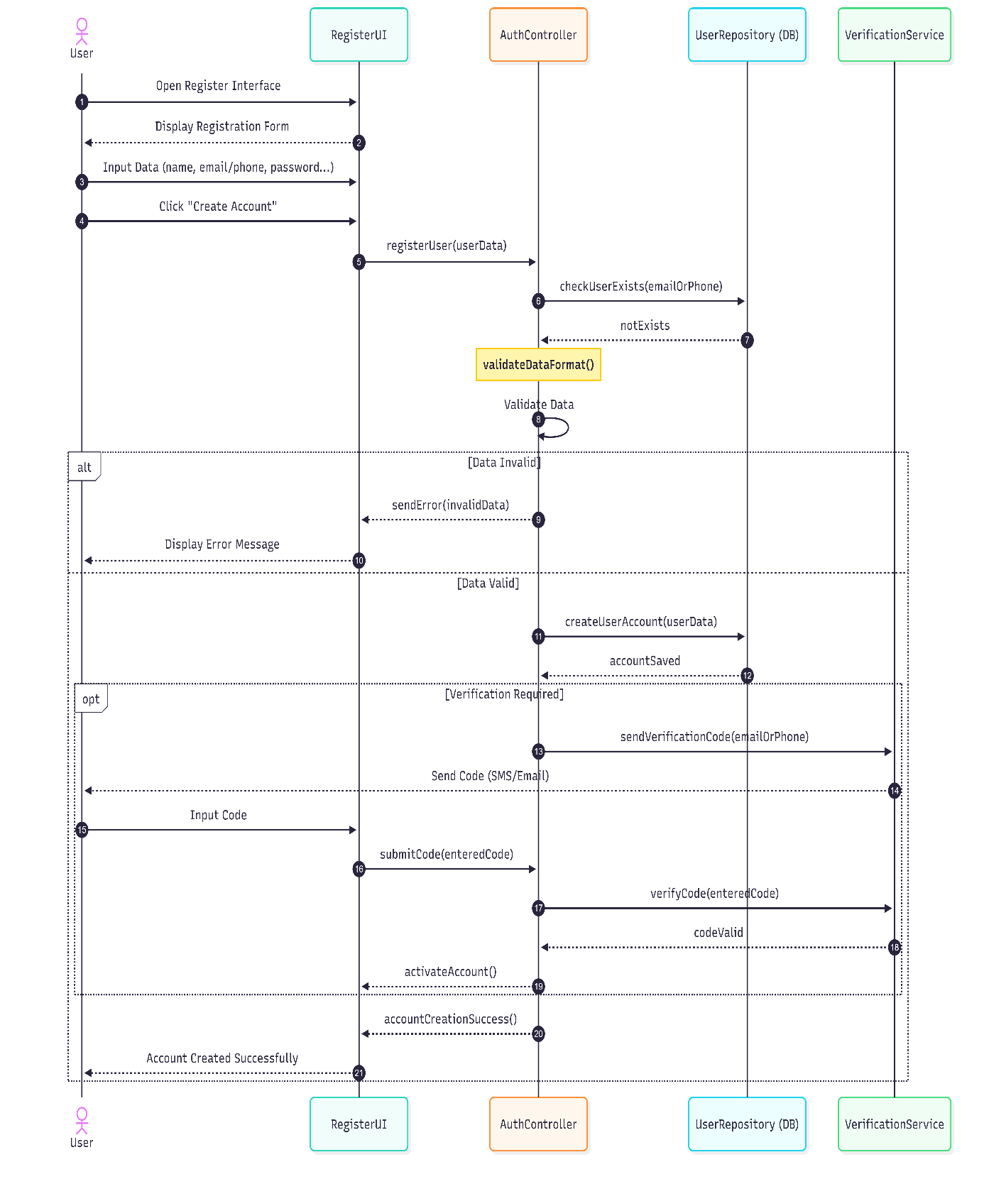
إنشاء حساب جديد

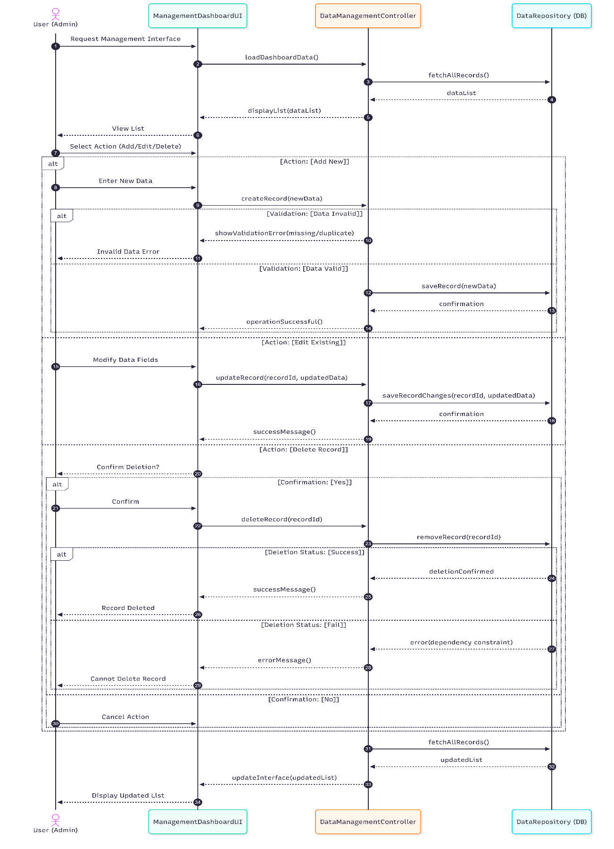
إدارة الادوية

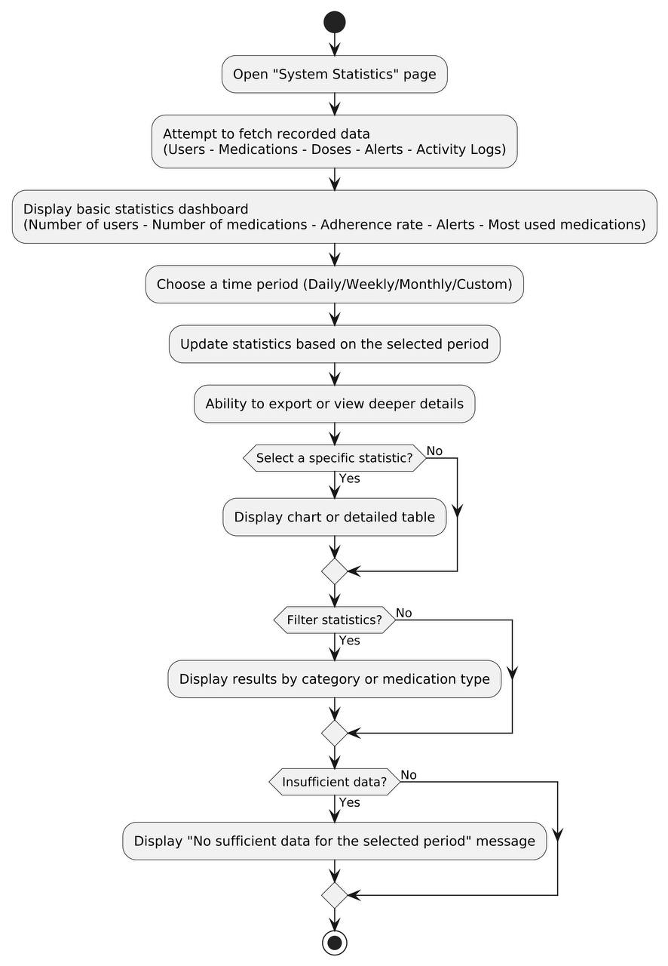
5.4 Activite Diagram:

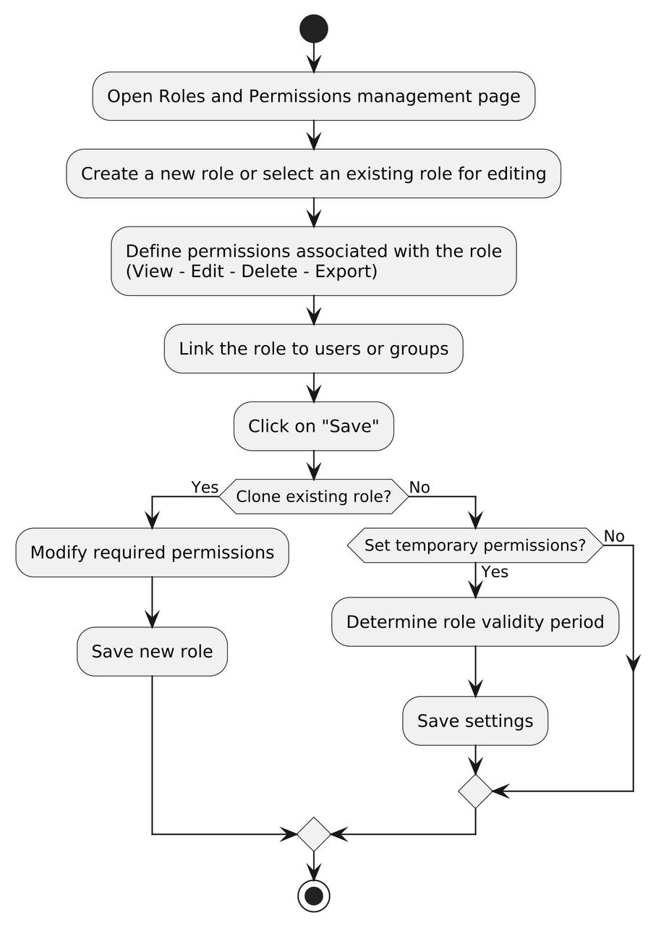

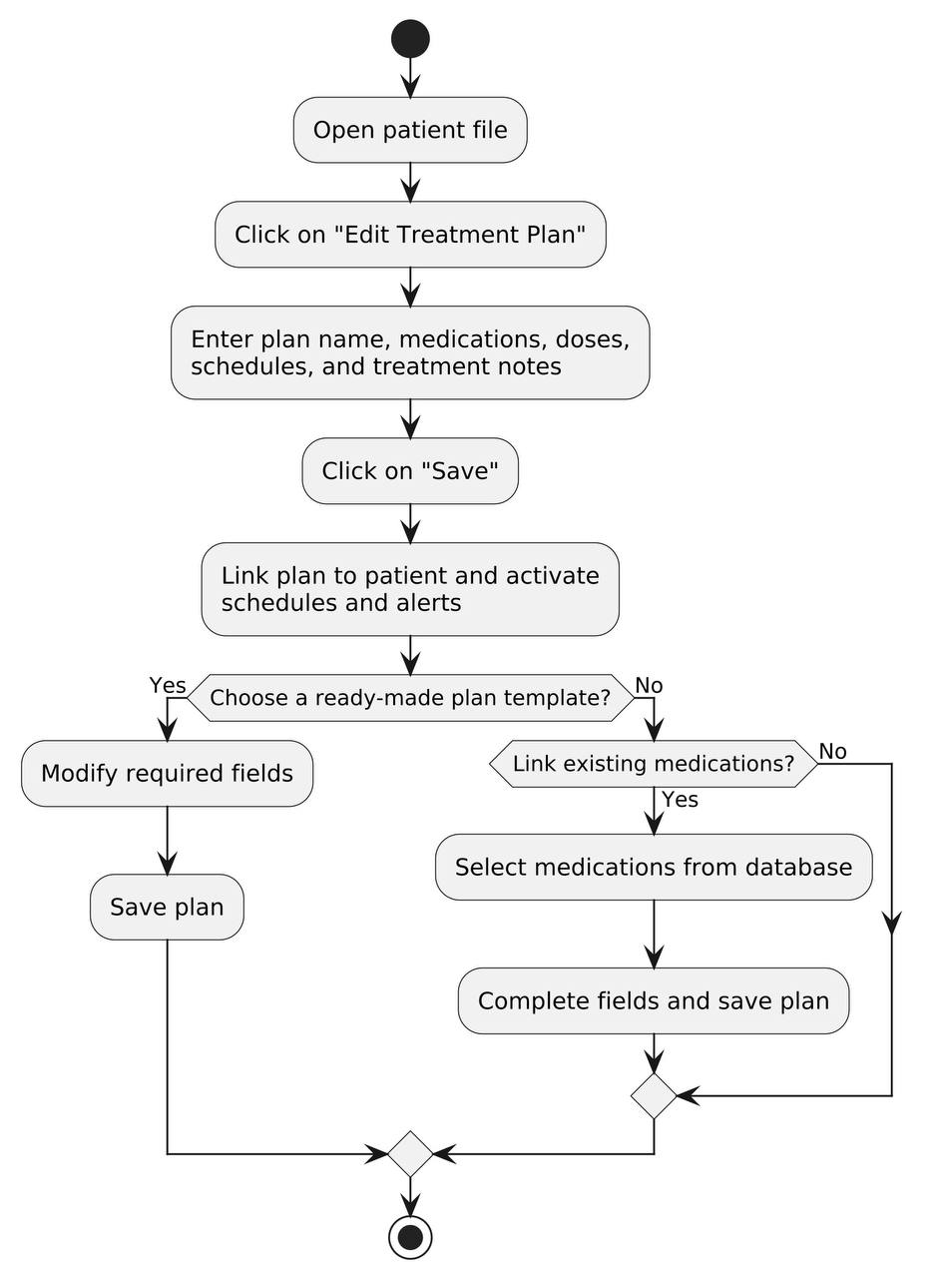
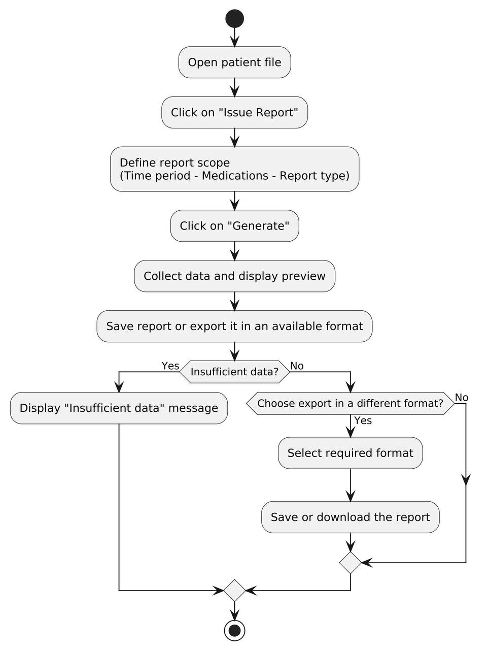

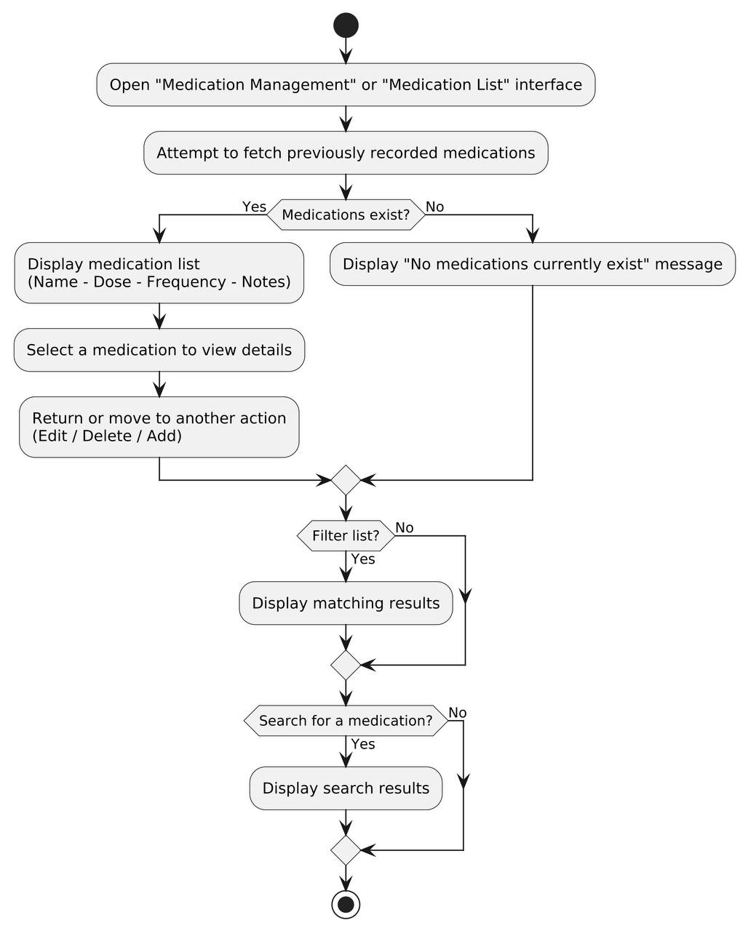
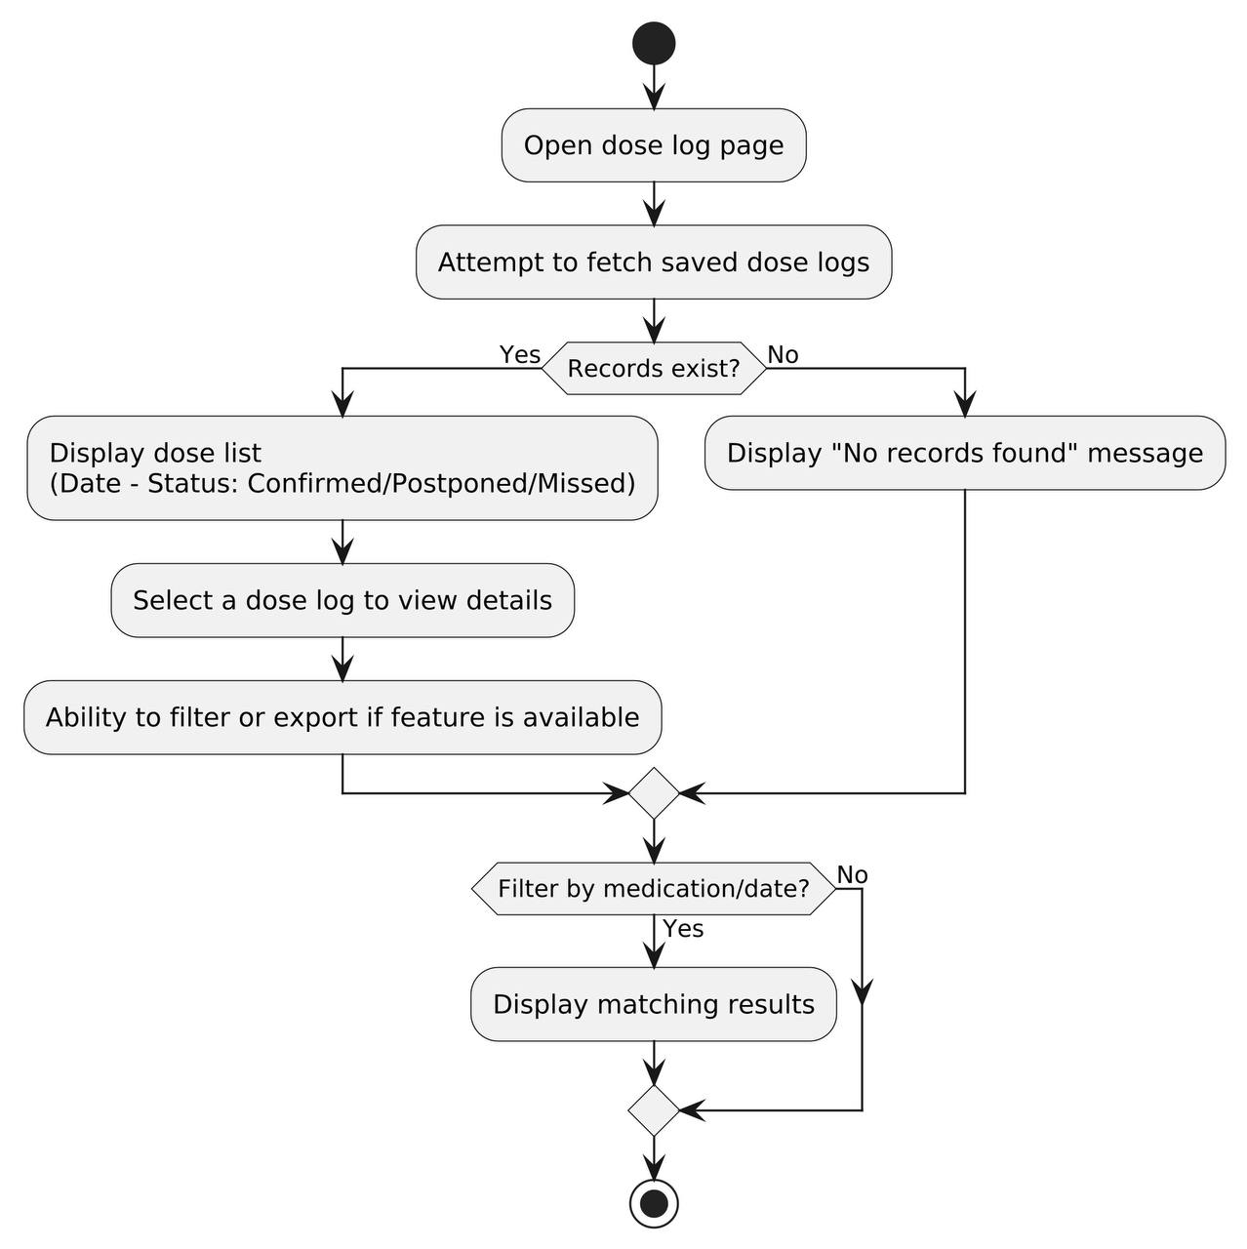
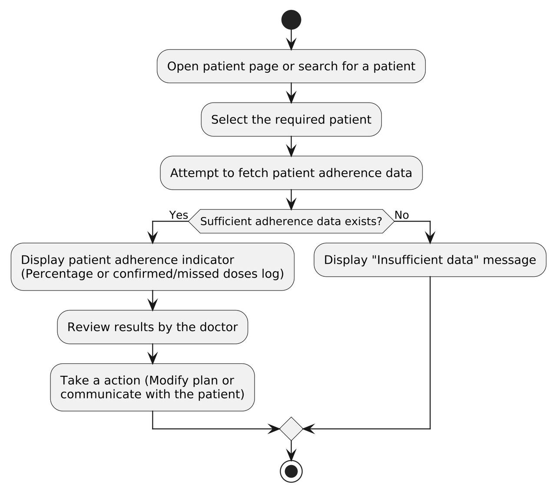
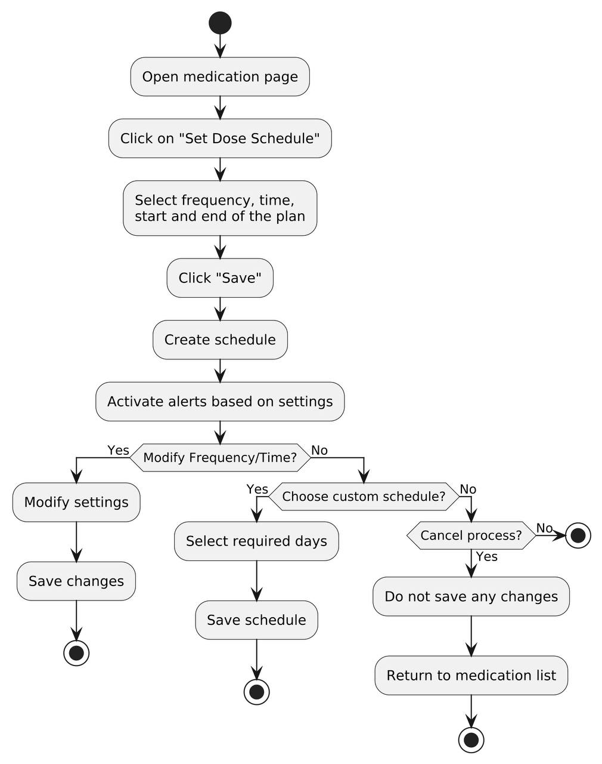
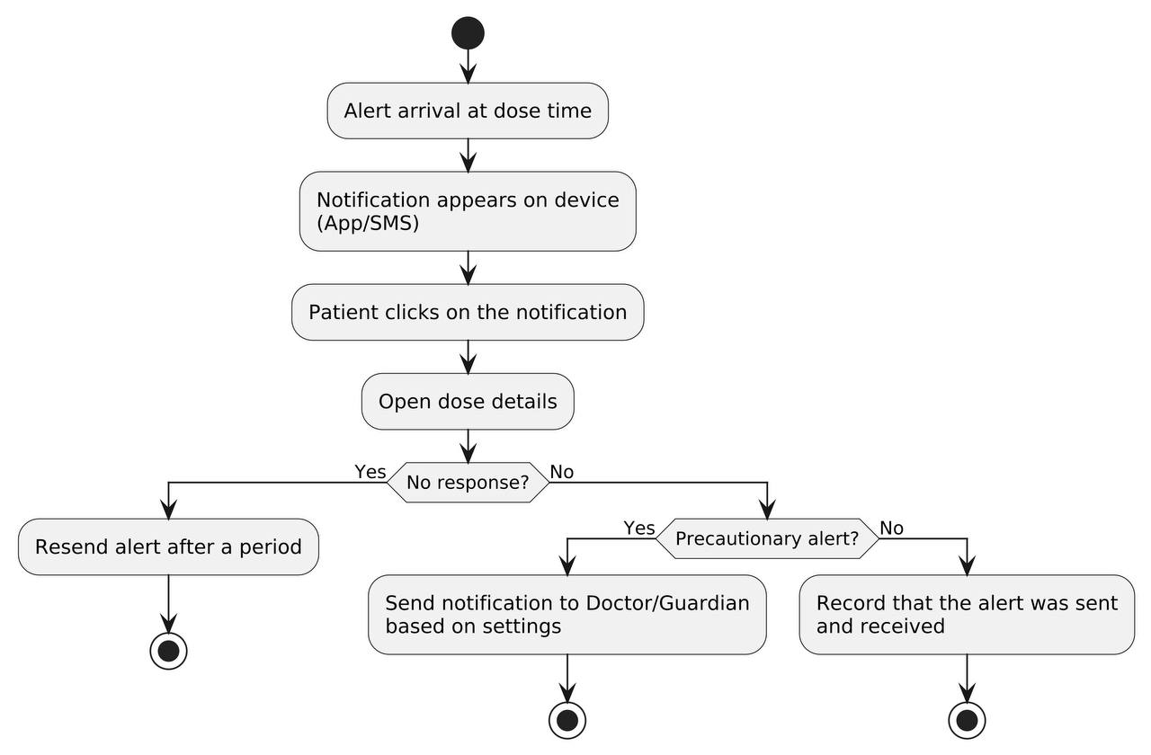
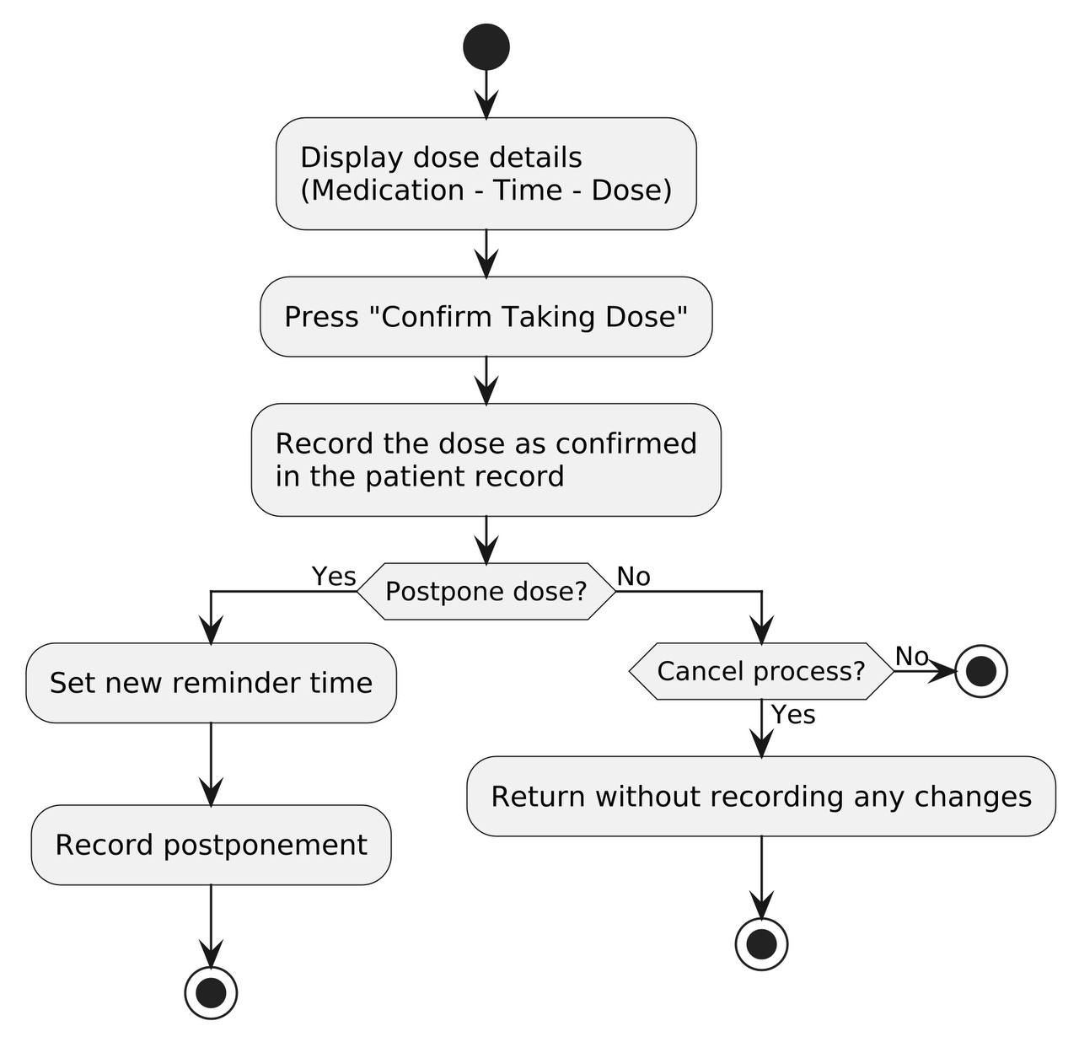
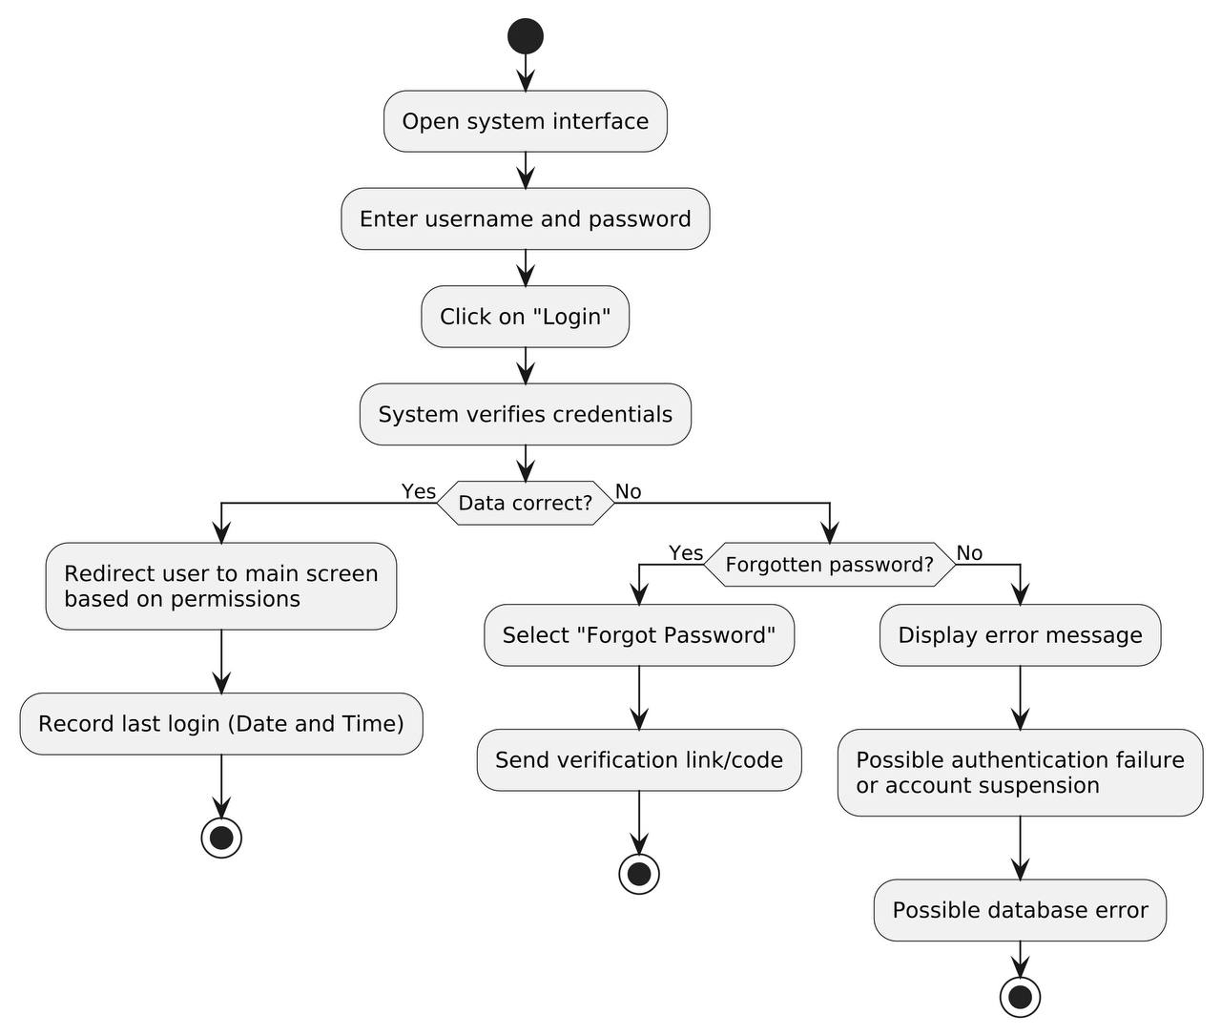
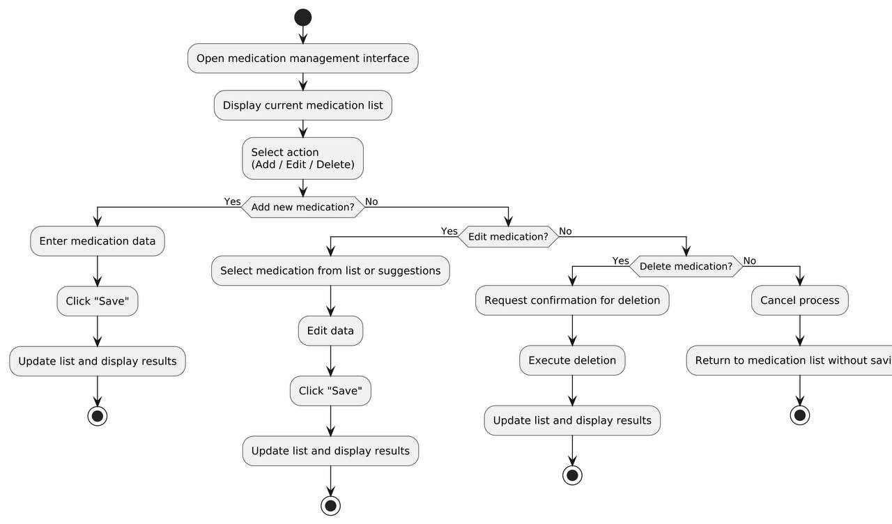
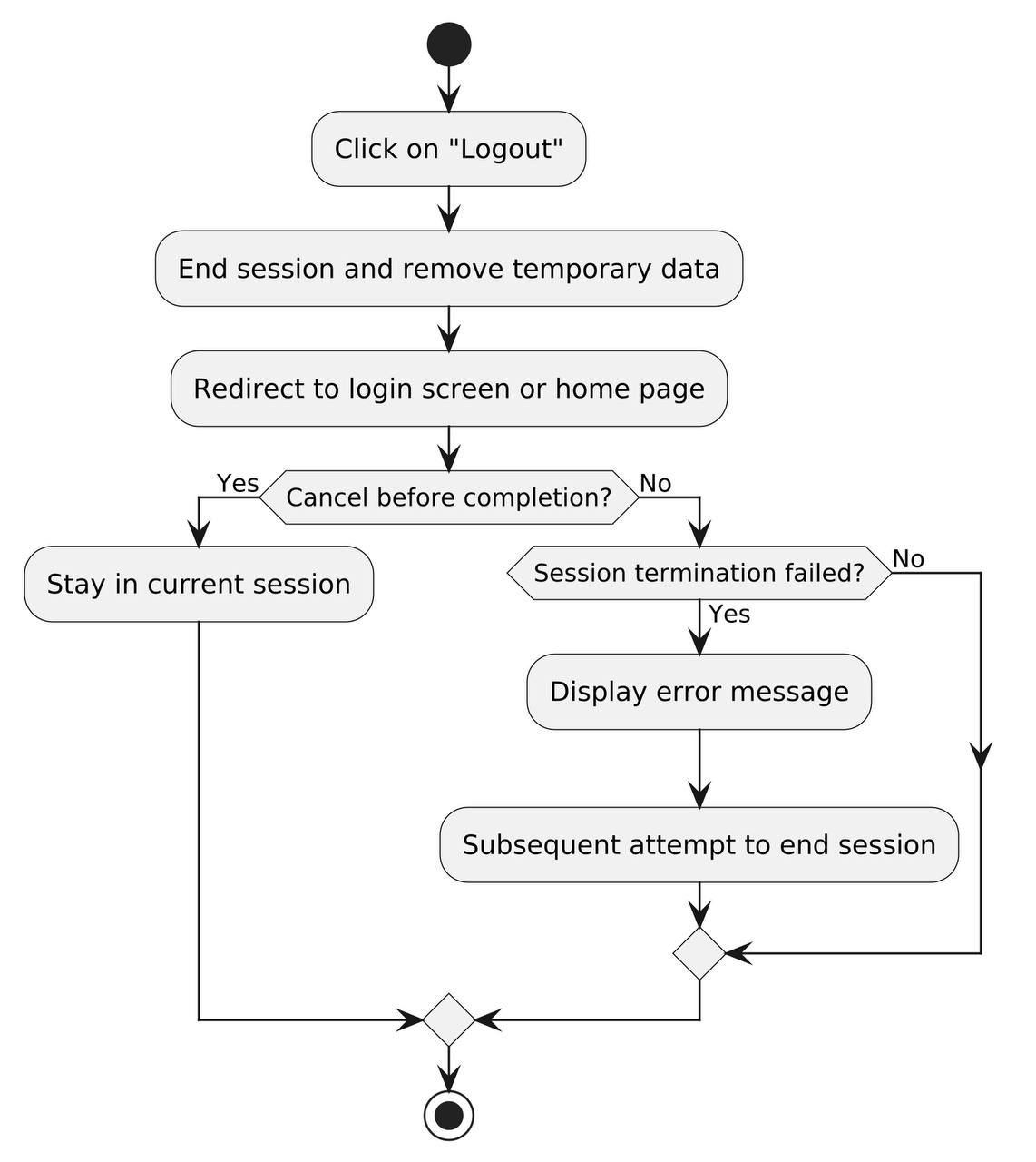
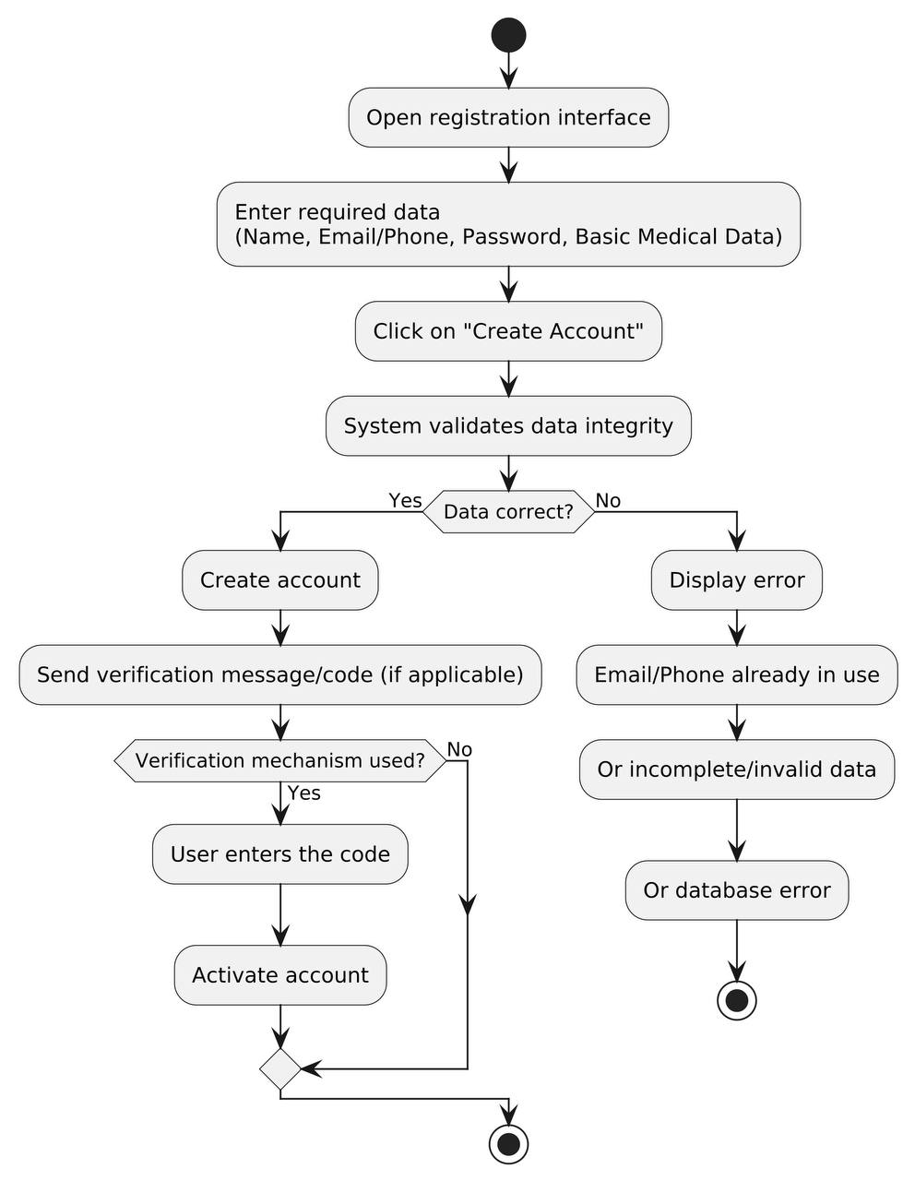

5.5 Analysis Class Diagram:

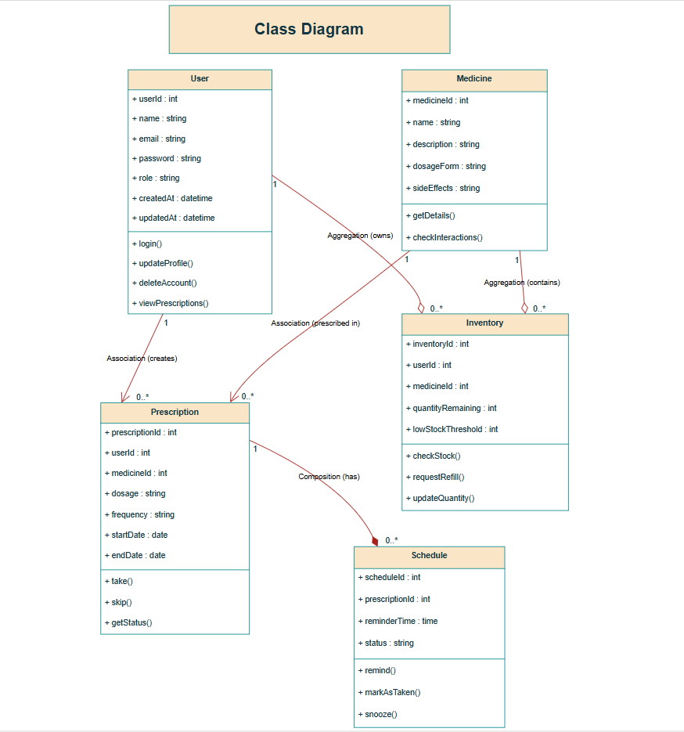
  - ERD Diagram:

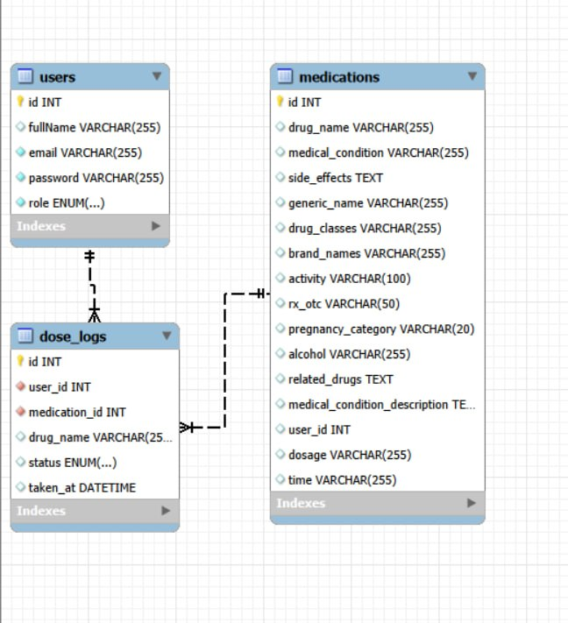

5.Initial Requirement Trackability Matrix (RTM):
Req_ID | Title | SRS Section | System Design
RE-FR-AU-1 | The system shall allow users to register a new account | FR(Register) | DFD1
RE-FR-AU-2 | The system shall allow users to log in securely | FR(Login) | DFD1
RE-FR-AU-3 | The system shall allow users to reset their password | FR(Reset_Password) | DFD1
RE-FR-MD-1 | The system shall allow users to add medicine | FR(Add_Medicine) | DFD2
RE-FR-MD-2 | The system shall allow users to view medicines | FR(View_Medicine) | DFD2
RE-FR-MD-3 | The system shall allow users to search for medicines | FR(Search_Medicine) | DFD2
RE-FR-MD-4 | The system shall allow users to edit medicine | FR(Edit_Medicine) | DFD2
RE-FR-MD-5 | The system shall allow users to delete medicine | FR(Delete_Medicine) | DFD2
RE-FR-PR-1 | The system shall allow doctors to create prescription | FR(Create_Prescription) | DFD3
RE-FR-PR-2 | The system shall allow users to view prescriptions | FR(View_Prescription) | DFD3
RE-FR-PR-3 | The system shall allow doctors to edit prescription | FR(Edit_Prescription) | DFD3
RE-FR-SC-1 | The system shall send reminders for medication doses | FR(Send_Reminder) | DFD4
RE-FR-SC-2 | The system shall allow users to mark dose as taken | FR(Mark_Taken) | DFD4
RE-FR-SC-3 | The system shall allow users to snooze a reminder | FR(Snooze_Reminder) | DFD4
RE-FR-IN-1 | The system shall track medicine inventory | FR(Track_Inventory) | DFD5
RE-FR-IN-2 | The system shall alert when stock is low | FR(Low_Stock_Alert) | DFD5
RE-FR-IN-3 | The system shall allow users to request refill | FR(Request_Refill) | DFD5
RE-FR-RP-1 | The system shall generate adherence reports | FR(Generate_Report) | DFD6
RE-FR-AD-1 | The system shall allow admin to view system statistics | FR(View_Stats) | DFD1
RE-FR-AC-1 | The system shall verify user permission before actions | FR(Check_Permissions) | DFD1

Analysis (Use Cases) | Detail Design | Coding
UC-01 Register | UserService.createUser() | RegisterController.java
UC-02 Login | AuthService.validateCredentials() | LoginController.java
UC-03 Reset Password | AuthService.resetPassword() | ResetPasswordController.java
UC-04 Add Medicine | MedicineService.add() | MedicineController.java
UC-05 View Medicine | MedicineService.get() | MedicineController.java
UC-06 Search Medicine | MedicineService.search() | MedicineController.java
UC-07 Edit Medicine | MedicineService.update() | MedicineController.java
UC-08 Delete Medicine | MedicineService.delete() | MedicineController.java
UC-09 Create Prescription | PrescriptionService.create() | PrescriptionController.java
UC-10 View Prescription | PrescriptionService.get() | PrescriptionController.java
UC-11 Edit Prescription | PrescriptionService.update() | PrescriptionController.java
UC-12 Send Reminder | ScheduleService.sendReminder() | ReminderScheduler.java
UC-13 Mark Dose Taken | ScheduleService.markAsTaken() | ScheduleController.java
UC-14 Snooze Reminder | ScheduleService.snooze() | ScheduleController.java
UC-15 Track Inventory | InventoryService.checkStock() | InventoryController.java
UC-16 Low Stock Alert | InventoryService.checkLowStock() | InventoryScheduler.java
UC-17 Request Refill | InventoryService.requestRefill() | InventoryController.java
UC-18 Generate Report | ReportService.generate() | ReportController.java
UC-19 View Statistics | StatsService.getStats() | AdminController.java
UC-20 Check Permission | AuthService.checkPermissions() | AuthMiddleware.java
Test Cases | Change Requests No
TC01_Register_Success | --
TC02_Login_Success | --
TC03_Reset_Email_Sent | --
TC04_Add_Medicine_Valid | --
TC05_View_Medicine_Valid | --
TC06_Search_Keyword | --
TC07_Edit_Medicine_Valid | --
TC08_Delete_Medicine_Permission | --
TC09_Create_Prescription | --
TC10_View_Prescription | --
TC11_Edit_Prescription_Valid | --
TC12_Reminder_Sent | --
TC13_Mark_Taken_Success | --
TC14_Snooze_Reminder | --
TC15_Check_Stock | --
TC16_Low_Stock_Alert | --
TC17_Refill_Requested | --
TC18_Report_Generated | --
TC19_View_Statistics | --
TC20_Permission_Denied | --

Chapter5

System Design

1. Introduction:
This chapter provides a comprehensive overview of the system design phase, which includes defining the overall architecture, designing internal components, and detailing each functional unit. It highlights the importance of this phase in building a robust and flexible Smart Medication Management System that fulfills the goals of healthcare monitoring, responds to patient needs, and contributes to continuous improvement in medication adherence and overall health quality.

2. System Architecture:
This section presents the system design, which includes defining the overall structure and software architecture, ensuring seamless integration and coordination among all components. This phase serves as the foundational blueprint that determines how medical data flows between users (patients/caregivers) and the system, and how different modules interact to ensure effective performance, security, and real-time alerting.

System Architecture Overview:
The development of the Smart Medication Management and Dose Alerting System was organized based on a Three-Tier Architecture within a Client-Server model. This architecture separates the Presentation Layer, Business Logic Layer, and Data Access Layer, making the development process more structured and maintainable while enhancing scalability and system reliability.

This architecture was fully adopted in the system, using modern technologies such as React for the frontend and Django (or your backend framework) for the backend, along with support for AI and OCR services to handle intelligent prescription data extraction and medication classification. Below is a brief explanation of each layer as represented in the system design:
- Presentation Layer: Receives user requests (such as uploading a prescription or viewing a dose schedule) through the web/mobile interface and routes them to the server via the API Gateway.
- Business Logic Layer: Contains the core functionalities of the system, such as dose scheduling algorithms, notification management, medication inventory tracking, and audit logging.
- Data Access Layer: Handles database operations using the Repository pattern, ensuring clear separation between business logic and the storage of patient records, medication data, and alerts.
- AI & OCR Microservices: Independent services responsible for processing images of prescriptions, performing text recognition (OCR), and intelligently classifying medications.

3. Component Diagram:
This section presents the overall structure of the Smart Medication Management System, showing how the front-end interfaces interact with the backend layers to process health data and execute operations like dose reminders.
The system consists of five main layers:
- Client (Presentation Layer): The user interface where patients interact with the system.
- API Layer: Manages communication between the client and the server.
- Business Logic Layer: Where dose logic and system rules are processed.
- Data Access Layer: Manages how medication schedules and user profiles are saved.
- Database Layer: The secure storage for all system data.

The system also includes independent AI Microservices connected to the Business Logic Layer to handle the automated analysis of medical documents.

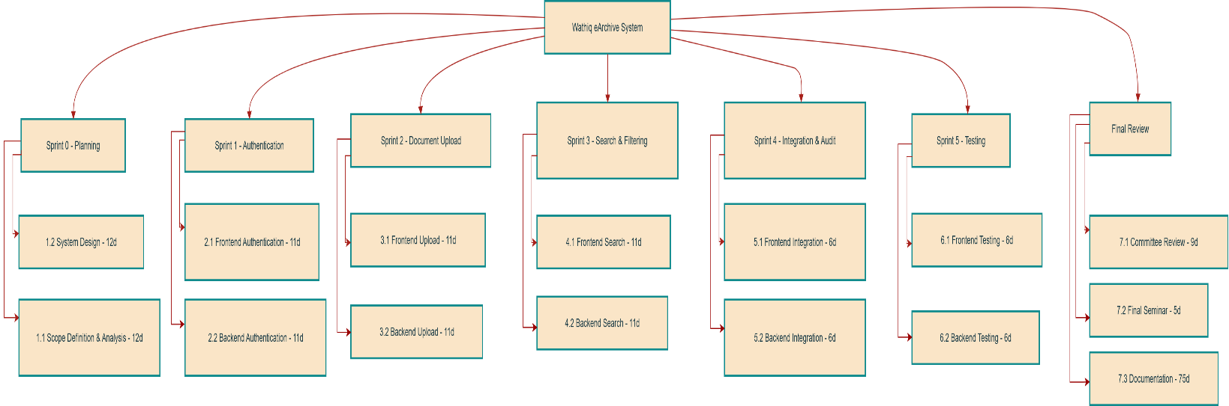

Component Functions
- Client Layer
• Enables the user (patient/caregiver) to interact with the system through the React UI interface.
• Allows sending requests and performing medication-related operations such as scheduling doses and viewing health status.
- Presentation Layer
• Controller: Receives requests from the interface (e.g., a request to add a new medication) and analyzes them.
• Routes the requests to the appropriate internal services within the backend.
- Business Logic Layer
• AI & OCR Microservice: Performs OCR on prescription images, extracting medication names, dosages, and instructions using intelligent text recognition techniques.
• Medication Management: Handles the core logic for adding, editing, deleting, and tracking medication inventory and schedules.
• Notification & Alert Service: Executes the scheduling logic to trigger real-time reminders and alerts for medication doses.
• Authentication & Authorization: Verifies user identity and manages access permissions to ensure medical data privacy.
• Audit & Reporting: Logs all system operations and generates adherence reports to track how consistently the user is taking their medication.
- Data Access Layer
• Repository: Manages structured access to data services and handles the intermediate processing between the business logic and the database.
- Database Layer
• Database & Storage: Securely stores metadata (user profiles, dose schedules, medication details) and original prescription images in an organized and encrypted manner.
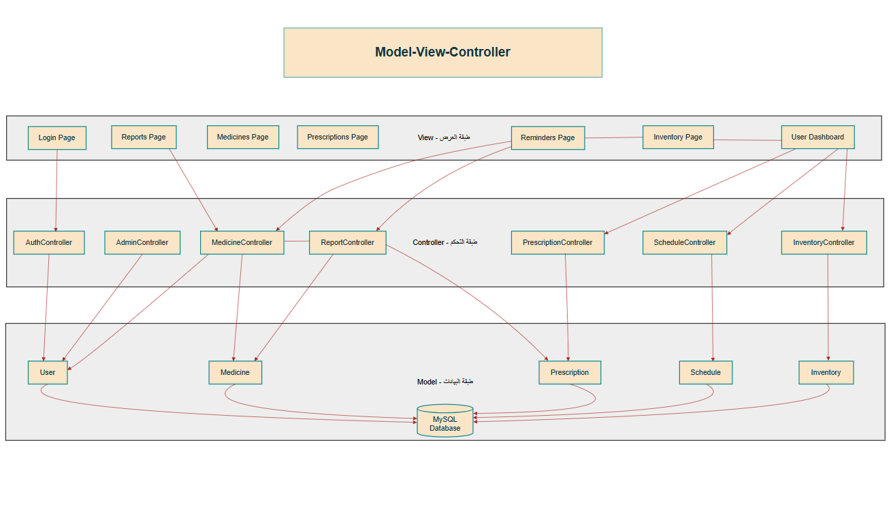

Chapter 6

Practical implementation

Introduction
This chapter provides a detailed overview of the practical implementation phase for the Smart Medication Management and Dosage Reminders system. Moving from theoretical architectural designs to execution, this section details the concrete environment configurations, language environments, and development tools deployed to construct the platform. By focusing on computational optimization and relational data safety, the discussion highlights how the selected modern development frameworks collaborate synchronously to sustain high system availability, secure medical data processing pipelines, and eliminate data latency during automated patient alert events.

Tools and Technologies Used

- React.js
React.js is a JavaScript library used to build interactive user interfaces and is one of the most popular tools for modern web development.
• It is based on the concept of components, which makes the code reusable and well-organized, especially for complex medication scheduling dashboards.
• It offers high performance through the Virtual DOM, enabling fast and smooth user interactions when navigating between doses and health reports.
• In this project, React.js was used to build the front-end, designing dynamic and responsive pages that allow users to easily manage their medications and view real-time alerts.

Backend Service Component: 2.
The centralized business logic and API orchestration are powered by a scalable Node.js runtime environment utilizing the Express.js framework. This asynchronous, event-driven backend layer is engineered to manage secure RESTful routing configurations, handle heavy concurrent validation loops, and distribute immediate alert synchronization protocols between remote doctor and patient clients. Moving away from legacy systems, this implementation acts as a secure controller that efficiently runs real-time dosage scheduling algorithms and manages notification rules without processing delays.
Database Management Component: 3.
Data persistence and referential integrity are secured through a structured MySQL relational database management system. This centralized storage architecture effectively maps, updates, and retains vital system entities, handling user security profiles, verified practitioner credentials, digital prescription logs, and current pharmaceutical inventory metrics. The MySQL database integrates tightly with the Node.js backend to perform fast query transactions, preventing data latency and maintaining strict structural keys across all operational tables during alert compilation routines.


‏General Website Home


System User Sign-In

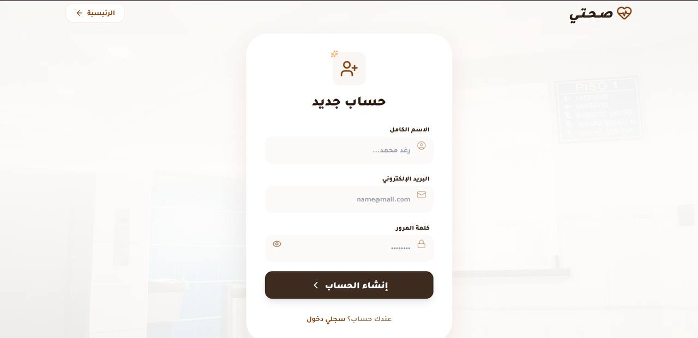
User Registration

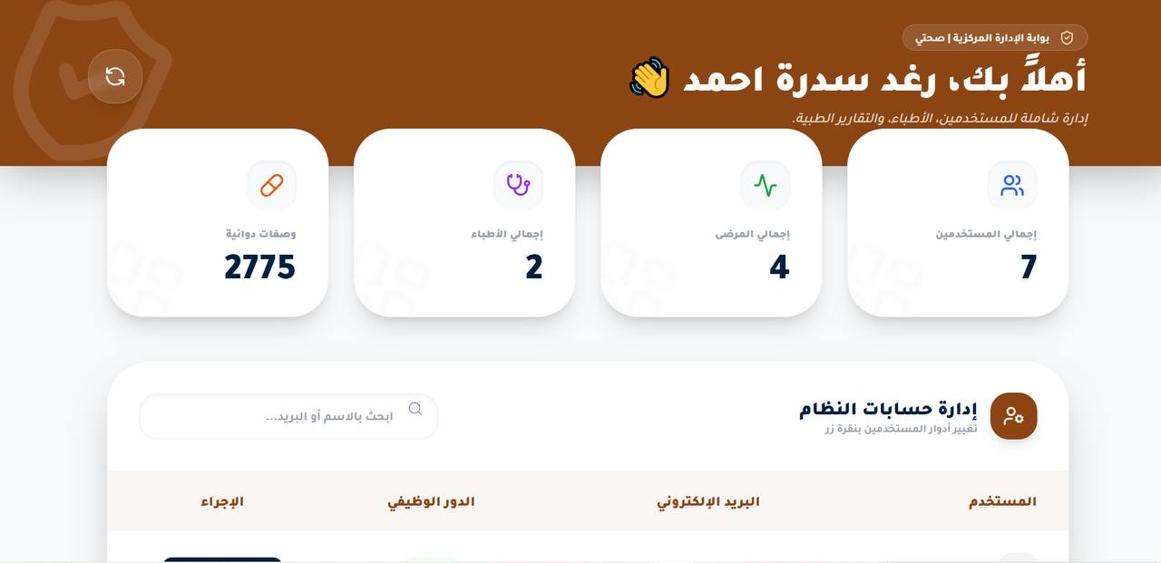
Admin Dashboard

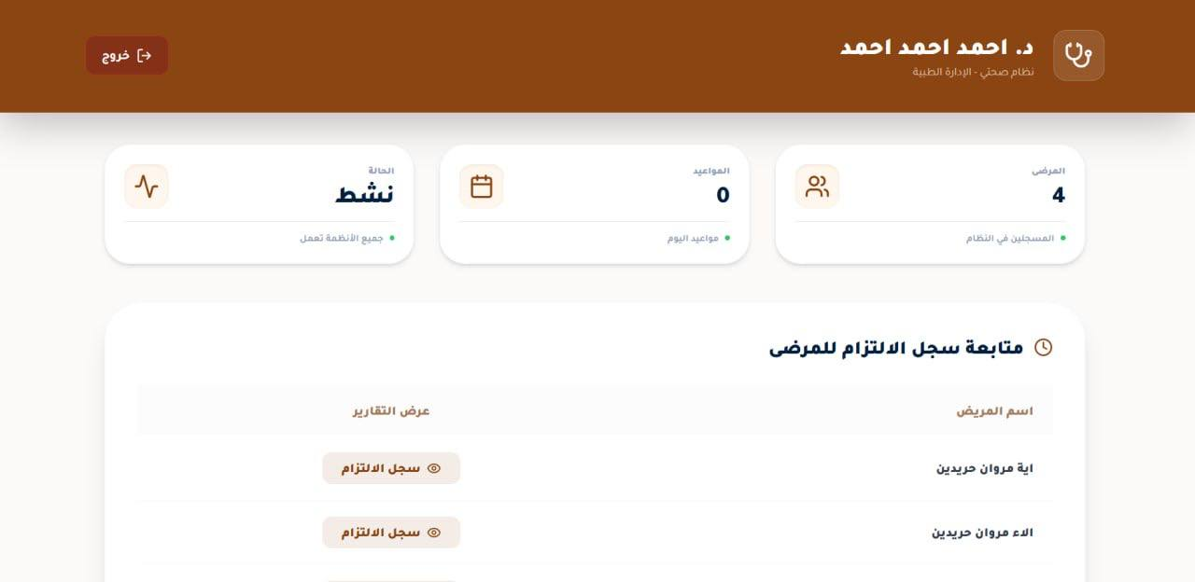
Doctor Dashboard

Treatment Plan

Add New Treatment
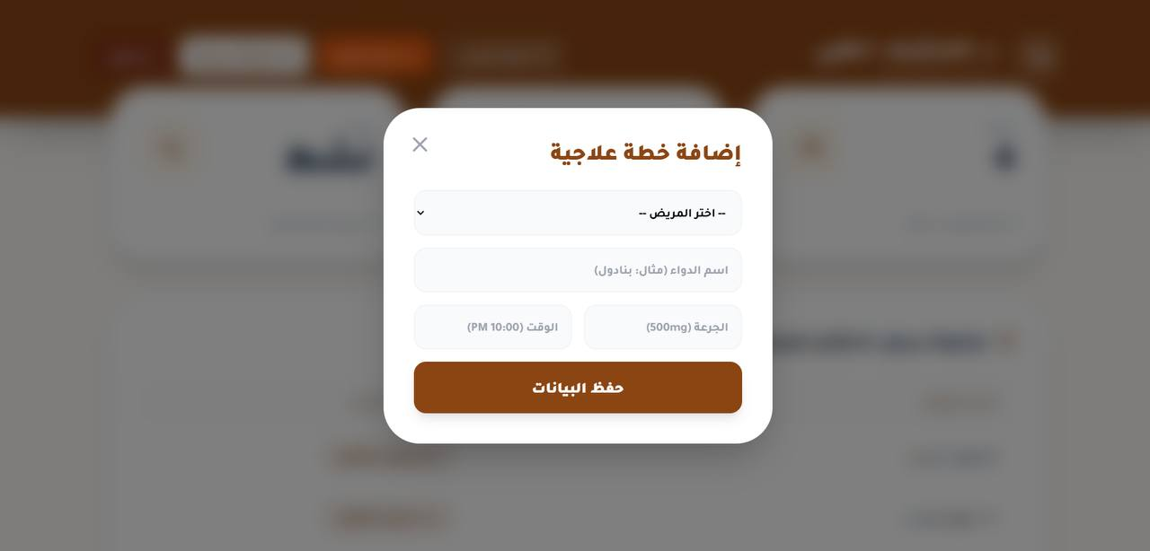

User Accounts
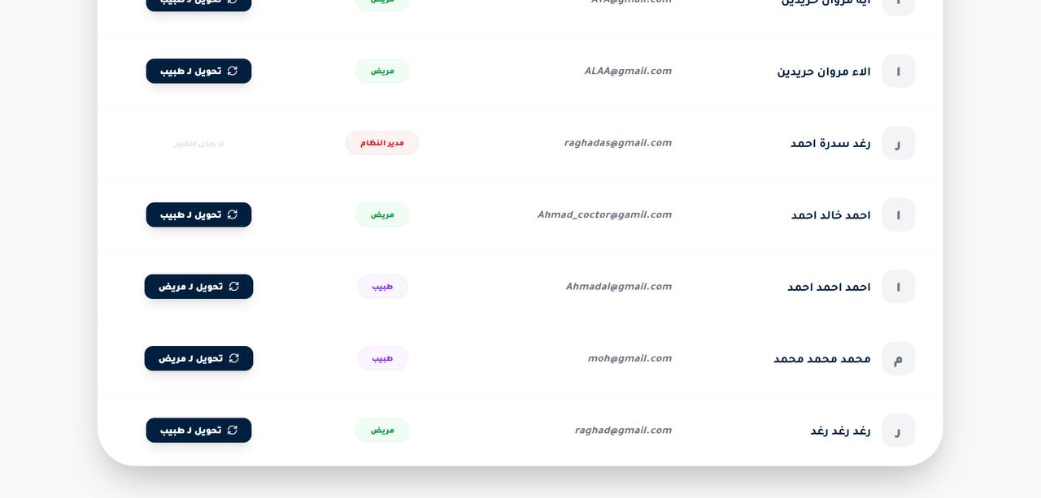

Doctor Navigation
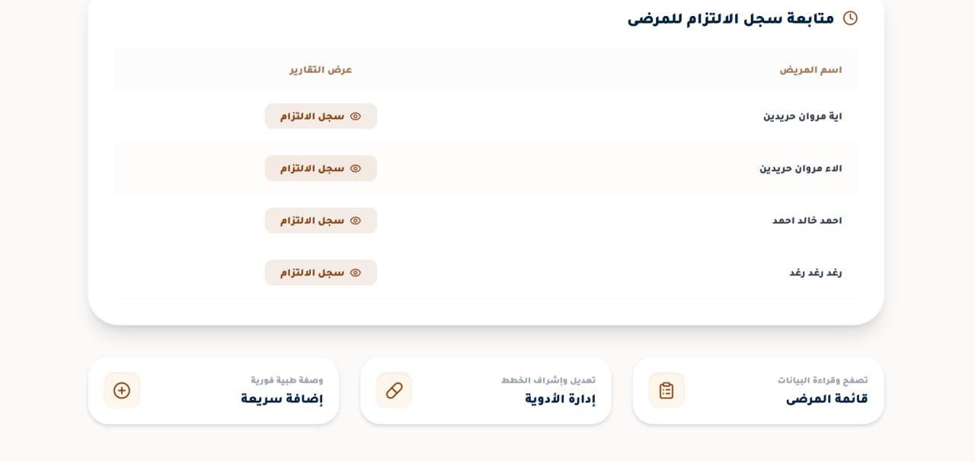

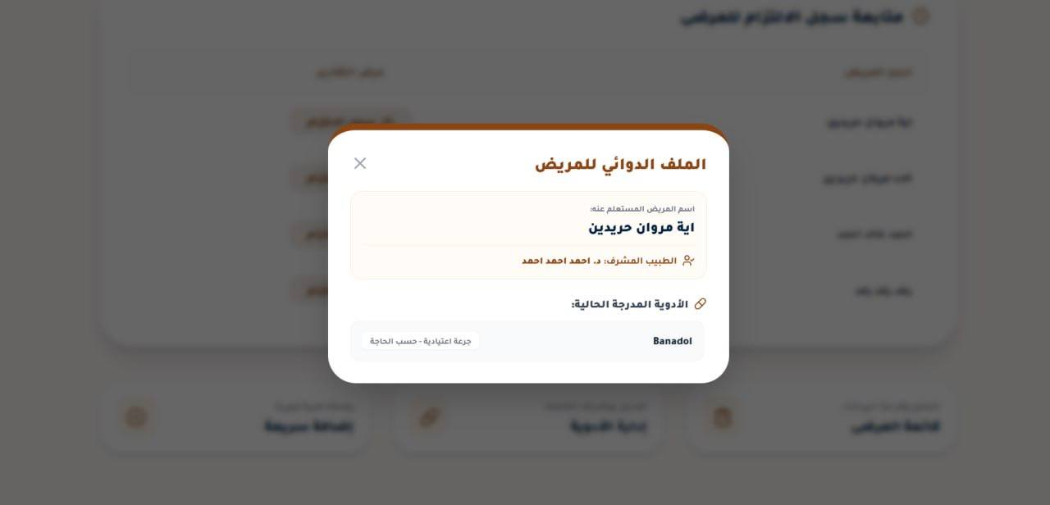
Patient Current

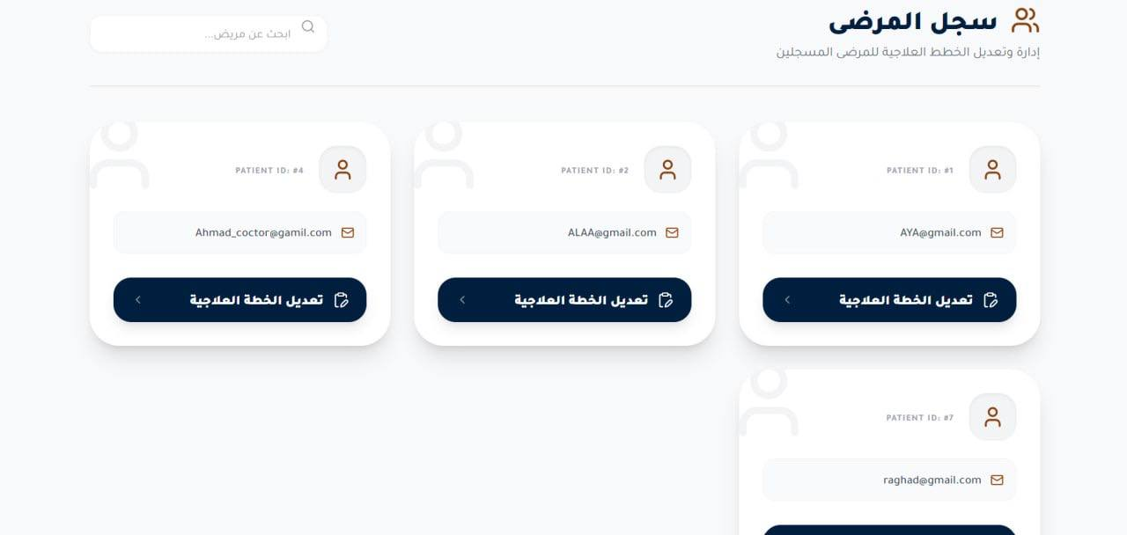
Registered Patients

Medication Intake Log
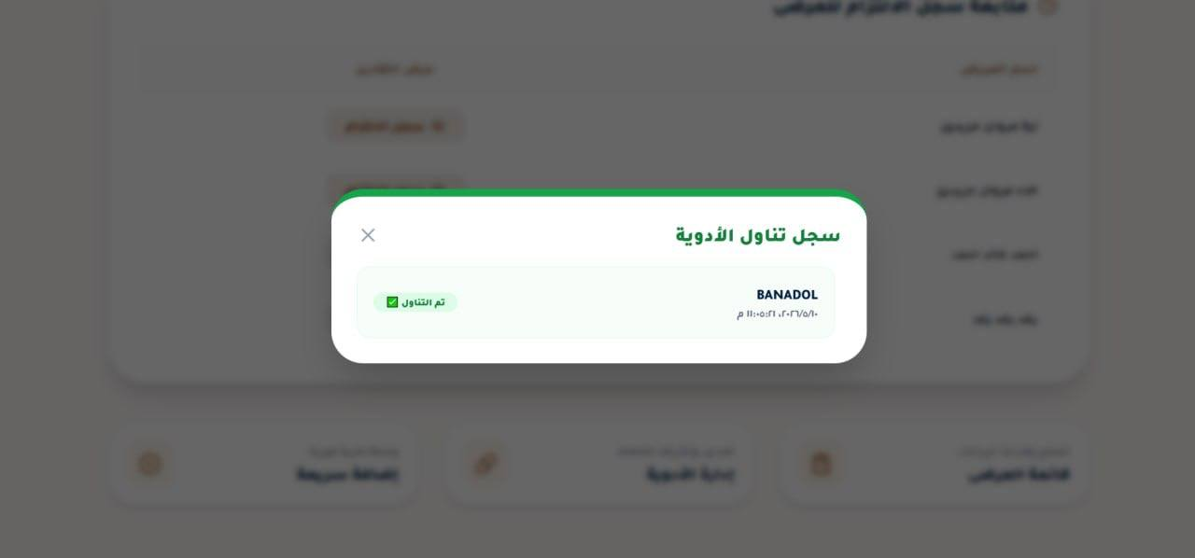

Patient Comprehensive
